Social Vulnerability
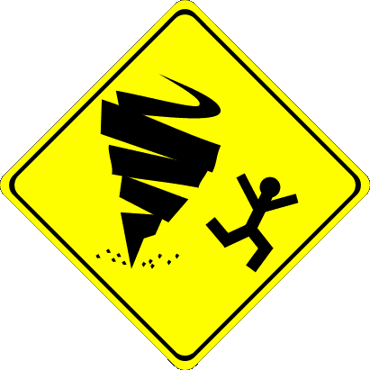

Research on social vulnerability represents:
- threats to the well-being of human populations and related economic losses, and also includes
- the relative potential for “physical harm and social disruption to subpopulations of societies and their larger subsystems based on socioeconomic status, age, gender, race and ethnicity, family structure, residential location and other demographic variables” (Cutter 2003 and NRC 2006).
- Vulnerability is determined by all of these elements in different combinations. Changing one element alters the vulnerability (Tobin 1997).

Exposure and vulnerability to hazard are not equal within societies, as is neither the willingness to prepare. Additionally, “cognition of risk influences behavior in the face of hazard, and risk perceptions are often amplified or attenuated by sociocultural and psychological processes” (Mitchell 1994). Ultimately, hazards are human events, and therefore social issues play a great role. Thus, qualitative research of people in high risk areas is a necessary contribution to quantitative work. Treating hazards as merely geological phenomena separates them from the social environment and ignores the human impact (Wisner 2005).

Resources on Vulnerability

Wisner, B., P. Blaikie, T. Cannon, I. Davis. (2005) At Risk: Natural hazards, people’s vulnerability and disasters. New York: Routledge.
*Click here for a review of the above book with a nice overview.

National Research Council of the National Academies. (2006) Facing Hazards and Disasters: Understanding Human Dimensions. Washington, DC: The National Academic Press.

Bankoff, G. (2001) “Rendering the World Unsafe: ‘Vulnerability’ as Western Discourse.” Disasters, 25(1): 19-35.
*Click here for a pdf version.

Cutter, S. et al. (2003) “Social Vulnerability to Environmental Hazards.” Social Science Quarterly, 84(2): 242-261.
*Click here for a pdf version.

Cutter, S. (2003) “The Science of Vulnerability and the Vulnerability of Science.” Annals of the Association of American Geographers, 93(1): 1-12.

Cutter, S. (2000) “Revealing the Vulnerability of People and Places: A Case Study of Georgetown County, South Carolina.” Annals of the Association of American Geographers, 90(4): 713-737.
*Click here for a pdf version.

Morrow, B. (1999) “Identifying and Mapping Community Vulnerability.” Disasters, 23(1): 1-18.
*Click here for a pdf version.

Sapountzaki, K. (2005) “Coping with seismic vulnerability: small manufacturing firms in western Athens.” Disasters, 29(2): 195−212.
*Click here for a pdf version.

Satterfield, T. et al. (2004) “Discrimination, Vulnerability, and Justice in the Face of Risk.” Risk Analysis, 24(1): 115-129.
*Click here for a pdf version.

Thomalla, F. et al. (2006) “Reducing hazard vulnerability: towards a common approach between disaster risk reduction and climate adaptation.” Disasters, 30(1): 39−48.
*Click here for a pdf version.

Mitchell, J., N. Devine, K. Jagger. (1994) “A Contextual Model of Natural Hazard.” In Environmental Risks and Hazards, S. Cutter (ed). Englewood Cliffs, NJ: Prentice Hall.

Tobin, G. and B. Montz. (1997) Natural Hazards: Explanation and Integration. New York: The Guilford Press.

