Social Science Research

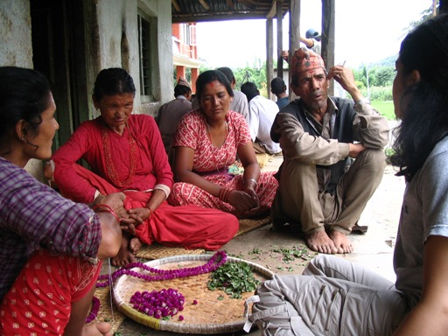
A photo taken in Nepal by Smriti Dahal for her M.S. research on women in community forestry (Summer 2006).

Ethnographic Methodology
Human Subjects
Risk Perception
Social Vulnerability
Case Studies

This page has been developed to give those not formally trained in the social sciences an idea about the research methods and theory relevant to studying human populations affected by hazards.

This page was created by Kate Graves, MS candidate in Environmental Policy at Michigan Technological University. All of the articles listed cannot be fully vouched for by the author, just offered as materials for literature review of the subjects. The materials contained use both quantitative and qualitative methods.

