Human Subjects

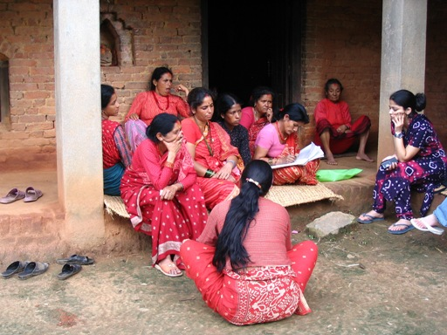
A women’s Community Forest User Group in Nepal, Photo by Smriti Dahal (Summer 2006).

When working with Human Subjects, you must have approval from your university’s internal review board. This is for your own protection, but mostly for the protection of your subjects.

Important things to remember:
- Awareness. They must be aware of what for and how you will be using the information you get from them.
- Confidentiality. Their names must not be attached to anything surrounding your research.
- Permission. They must consent to participating, and to the use of what they give you. They also must consent to any recording devices that might be used.

Before beginning you should begin with a statement explaining your research and how it will be used. Then you should follow with a statement similar to this:

We appreciate your willingness to participate in our research. Although we won't be asking very sensitive questions, all of your statements and answers will be confidential. Your name will never be associated with anything that you tell us. Your answers will be used solely for research purposes.

Although I'll be taking notes as we talk, it helps us to have a complete record of what you say if I can also tape record our conversation. Are you comfortable with this?

Here is Michigan Tech’s Human Subjects Review Board website with additional information: http://www.admin.mtu.edu/research/vpr/reviewboards/human.html

Michigan Tech’s training recommendations: http://www.admin.mtu.edu/research/vpr/reviewboards/humantraining.html

