Izalco volcano fumarole temperature measurements
July 2007
SNET and Michigan Tech University

On July 3, 2007, volcanologists from SNET, University of El Salvador and Michigan Tech University climbed Izalco volcano to make measurements of fumarole temperatures and gas emissions. This report details the fumarole measurements by SNET and MTU using thermocouples as well as an Extech 42545 radiometer.

Temperatures were measured at twelve fumarolic areas which are revisited by SNET on a regular basis, and these comprise the vast majority of active fumarolic areas at Izalco (one minor fumarolic area on the south crater rim was not measured). Most of these areas are near the northern crater rim.

Temperatures at the twelve areas ranged from 55.9 to 83.3 °C, and the gas lacked any smell suggesting water vapor only. A map of the fumarolic locations and corresponding temperatures is shown below. These values are similar to recent measurements by SNET, and are also consistent with the last GVN report from Dec. 1999 (BGVN 24:12) which reported water vapor fumaroles with a maximum temperature of 86 °C.

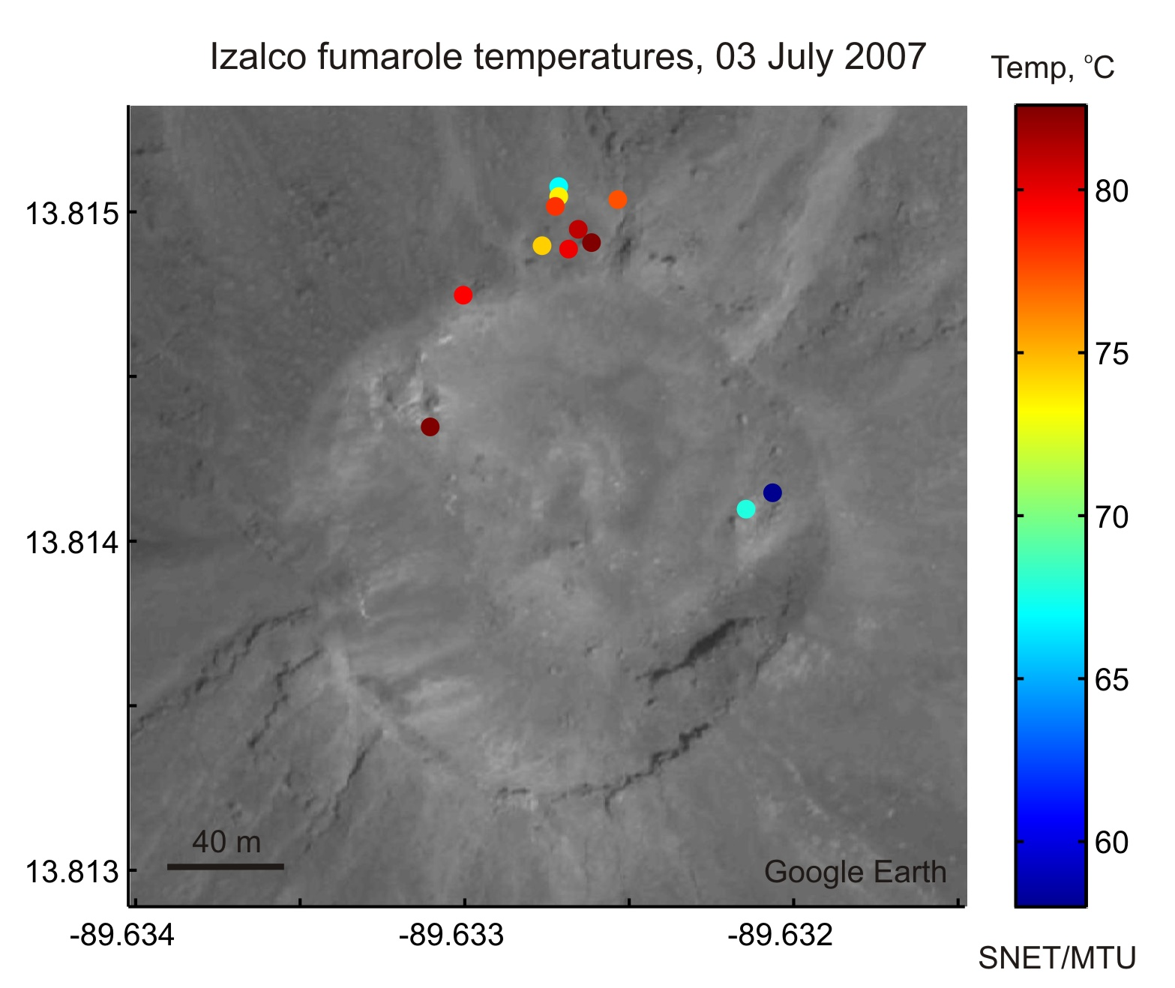

The agreement among the SNET and MTU thermocouples and the radiometer was generally very good. The mean range among these three instruments for the twelve fumarolic areas was 2.6 °C.

The active fumaroles may explain the apparent warm anomaly at the summit of Izalco observed in nighttime longwave (Band 14, 11 microns) IR ASTER imagery. The warm anomaly has been consistent among multiple images, as shown below:

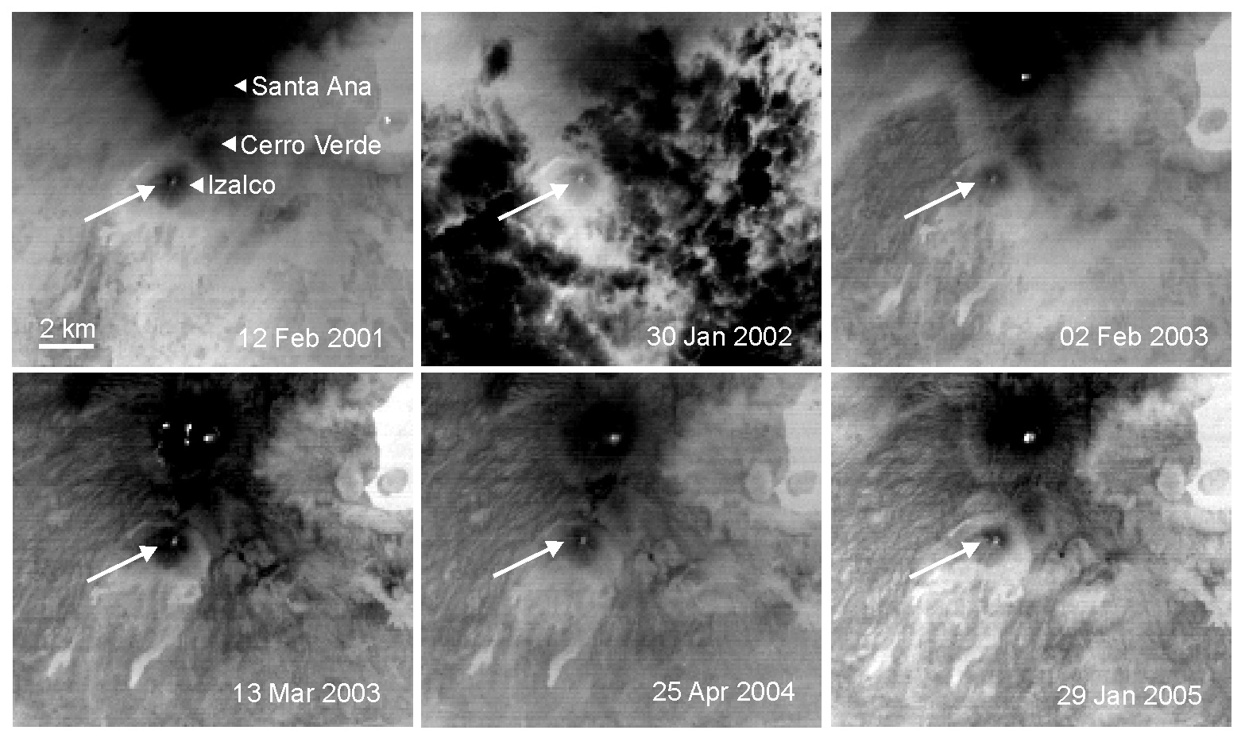

Information contacts:
Demetrio Escobar (descobar@snet.gob.sv) and Francisco Montalvo (fmontalvo@snet.gob.sv). Servicio Nacional de Estudios Territoriales, SNET, Km. 5 1/2 carretera a Santa Tecla y Calle las Mercedes, contiguo a Parque de Pelota, Edificio SNET. Apartado Postal #27, Centro de Gobierno, El Salvador
Tel: 2223-7792; 2282- 2241; 2283-2246 (URL: http://www.snet.gob.sv/); Matthew Patrick and Anna Colvin, Dept. of Geological and Mining Engineering and Sciences, Michigan Tech University, 1400 Townsend Drive, Houghton, MI 49931, USA (Email: mpatrick@mtu.edu; ascolvin@mtu.edu).

