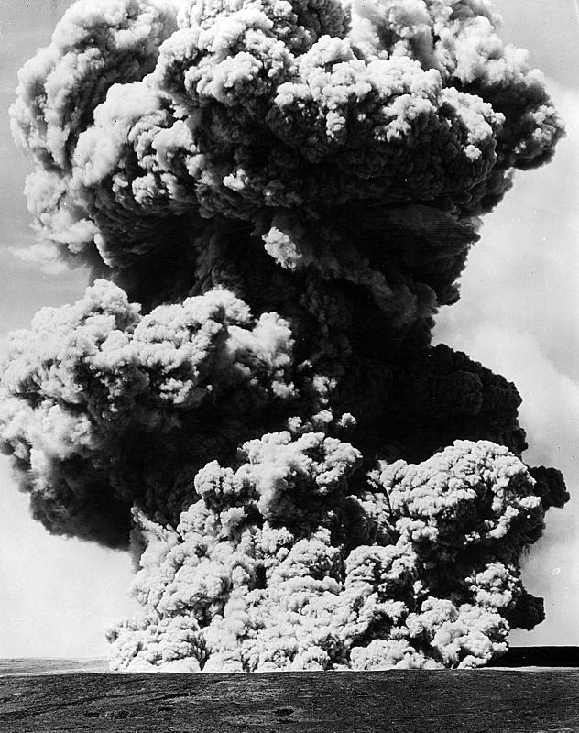

Halemaumau eruption, 0935 on May 13, 1924. Photo by Oliver Emerson, taken from near Kilauea Military Camp.

