July 11, 2006
Element Fluxes from the Volcanic Front of Nicaragua and Costa Rica

Michael J. Carr, Ian Saginor
Rutgers University, Department of Geological Sciences, 610 Taylor Rd., Piscataway NJ 08854-8066

Guillermo E. Alvarado

Seismology and Volcanology, Instituto Costarricense de Electricidad, Apartado 10032-1000, Costa Rica

Louise L. Bolge*, Fara N. Lindsay, Brent Turrin, Mark D. Feigenson and Carl C. Swisher III
Rutgers University, Department of Geological Sciences, 610 Taylor Rd., Piscataway NJ 08854-8066

* Now at Department of Earth Sciences, Boston University, 685 Commonwealth Ave.
Boston MA 02215

Abstract

[1] New geochronologic and geological data define a 600 ka age for the beginning of the current volcanic front in Costa Rica. The primary change at that time was a near cessation of volcanic activity in the gap between the Cordillera de Guanacaste and the Cordillera Central. A basal age for the two volcanic segments in Nicaragua is estimated at 350 ka but this datum is less well established than the basal age for Costa Rica. The new geochronologic data, along with revisions to the volumes of Costa Rican volcanoes, provide a difference in extrusive volcanic flux between western Nicaragua (1.15 x 10¹⁰ kg/m/Ma) and central Costa Rica (2.26 x 10¹⁰ kg/m/Ma) that is greatly reduced from previous estimates. These volcanic flux rates are about a factor of 10 lower than rates for other convergent margins due to a more conservative method used to calculate volcano volume. We estimate the subducted component of flux for Ba and other elements with very large enrichments over plausible unmodified mantle compositions. For such elements the uncertainly about the actual mantle composition beneath Central America becomes a minor factor in calculating the subducted component of element flux. Averaged over the time of the current episode of volcanism (600 ka in Costa Rica and 350 ka in Nicaragua), the subduction component of fluxes of Cs, Rb, Ba, K and Sr are not significantly different among the four segments of the Central American volcanic front in Nicaragua and Costa Rica. Although the regional variations in some prominent sediment signals, ¹⁰Be/⁹Be and U/Th, may be explained by differential sequestering of just the uppermost subducting sediments, this mechanism cannot be used to explain the well defined regional variation in Ba/La or the constancy in the fluxes of Cs, Rb, Ba, K and Sr. Therefore, the large regional changes in subduction signal most likely result from changes in the mode or mechanics of flux delivery and its processing into melt.

Keywords: Central America, subduction factory, element flux, magma production rate

1. Introduction

[2] The cycling of incompatible elements at convergent plate margins, especially the elements more mobile in melts or hydrous fluids, has become well established since the development of plate tectonics [e.g. Gill, 1981]. Specific sources and fluids, coupled with melting and mixing models, have been identified for different arcs; e.g. Elliot et al. [1997] and Stolper and Newman [1994] for the Izu-Bonin-Marianas system; Eiler et al. [2004] for Central America; Kelemen et al. [2003] for the Aleutians. The large variety of subducted inputs has created considerable diversity among the different convergent margins in their volcanic output [Plank and Langmuir, 1988].

[3] Although much progress has been made in understanding the magma generating processes in the subduction factory beneath arc volcanoes, few steps have been made toward the goal of calculating a mass balance across a convergent margin. To quantitatively model element cycling at convergent margins, one must be able to balance the subducted input, the slab and its thin sediment cover, against multiple actual and potential outputs, including mud volcanoes and other shallow releases of fluids and metamorphic products, the volcanic front, the back arc, and transport into the deep mantle. The largest and most easily measured output is the volcanic front and reliable measurement of the flux of subducted incompatible elements out of the volcanic front is an important goal for convergent margin research.

[4] In Central America, the flux of subducted highly incompatible elements out of the volcanic front was estimated by Patino et al. [2000] and Plank et al. [2002]. However, the age control used was inadequate, consisting of only a few very widespread and thick tephra units that were present in piston cores, allowing age determinations from marine stratigraphy [e.g. Ledbetter, 1985]. We present more accurate flux determinations using ⁴⁰Ar/³⁹Ar age determinations of lava flows at the bases of the presently active volcanic centers. The new ⁴⁰Ar/³⁹Ar data also permit us to refine our previous estimates of the volumes of the currently active volcanoes in Costa Rica.

[5] For several reasons, Central America (Figure 1) is an excellent place to make estimates of element fluxes from the volcanic front, especially for elements largely derived from subducted sediment. First, there is a satisfactory geochemical data base posted at http://www.rci.rutgers.edu/~carr/ and derived from Carr and Rose, [1987]; Patino et al., [2000] and Carr et al., [2003]. Second, from Guatemala to western Costa Rica, there is little or no sediment accretion [von Huene and Scholl, 1991] removing a major potential variation in input. However, in central Costa Rica, there is strong evidence for subduction erosion [Ranero and von Huene, 2000; Vannucchi et al., 2001], which may complicate the flux estimate in that region. Third, ¹⁰Be/⁹Be, an unambiguous tracer of sediment input, reaches its global maximum at Masaya volcano in Nicaragua [Reagan et al., 1994]. Fourth, several geochemical tracers of subducted sources [e.g. ¹⁰Be/⁹Be, ⁸⁷Sr/⁸⁶Sr, Ba/La, U/Th] have large and regular geographic variations that allow comparison of regions of high sediment signal, western and central Nicaragua, to nearby regions of low sediment signal, central Costa Rica [Carr et al., 2003 and references therein]. These areas in close geographic and tectonic proximity share substantial geologic history, yet have very different geochemistry for the highly incompatible elements that define the typical convergent margin volcanic geochemistry: enrichment in Cs, Rb, Ba, U and K and depletion in Nb and Ta.

[6] The regional gradients in tracers of subducted slab define a chevron with its peak at about the center of the margin: Ba/La shows this clearly (Figure 2a). La/Yb varies inversely with Ba/La, although its pattern is distorted by the high La/Yb values in central Costa Rica (Figure 2b), which has a demonstrably different mantle source; e.g. Feigenson et al., [2004]. For a uniform source, La/Yb is inverse to the degree of melting and so the regional variation in La/Yb in Central America is most likely a proxy for degree of melting (with the exception of central Costa Rica with its different geochemistry). Therefore, the primary regional geochemical variation that characterizes Central America is a positive correlation between slab signal, Ba/La, and degree of melting, inverse of La/Yb. If we can show that the flux of fluid mobile elements has the same regional variation as the slab signal then we must seek explanation for the regional variations in the amount of flux. If the flux does not vary along the margin, then the mode or mechanics of flux delivery and processing into melt must vary. This is the main question we seek to answer here.

[7] There are substantial difficulties in making estimates of element fluxes in Central America. The mantle source is not homogeneous because there is clearly an OIB source affecting Central Costa Rica [Feigenson et al., 2004]. Throughout the rest of the margin the mantle source may consist of at least two components, a MORB source and a less depleted source [Feigenson et al., 1993]. Furthermore, the subducted oceanic crustal section is complex with an East Pacific Rise MORB crust outboard of Nicaragua and northwestern Costa Rica and a Cocos-Nazca Ridge MORB crust outboard of Central Costa Rica [e.g. von Huene et al. 2000]. The sedimentary stratigraphy includes two units with large differences in geochemistry: a basal carbonate section of roughly 200 m and an upper hemipelagic section of roughly 200 m [Patino et al., 2000].

[8] Measuring volcanic output is difficult for many reasons. One major difficulty is the paucity of estimates of the erosion rate of the volcanic edifices. Similarly, there are few constraints on the partitioning of magmatic production into deep intrusives, shallow subvolcanic intrusives and effusive lavas and tephras. The last two outputs can be measured and that flux is our primary focus.

[9] To provide more accurate estimates of volcanic fluxes, we report new ⁴⁰Ar/³⁹Ar ages on lava flows exposed at the bases of the presently active volcanic centers in Costa Rica and Nicaragua. These lavas are considered representative of the oldest exposed flows from these active centers (we fully recognize that older, buried flows may exist). In addition to providing maximum ages for the active centers, the new ages also allow us to refine previous estimates [Carr et al., 2003] of the volumes of the currently active volcanoes in Costa Rica. Our results add to a growing body of geochronological data, improving on earlier K-Ar measurements [e.g. McBirney et al., 1974]. Ehrenborg [1996] and Plank et al. [2002] recently summarized the previous geochronological work in Nicaragua. Alvarado et al. [1992] summarized the instrumental ages of Costa Rican volcanics and Gillot et al. [1994] provided several new K-Ar ages and estimates of the volume of the major volcanic units. A substantial number of new ⁴⁰Ar/³⁹Ar ages have allowed Gans et al. [2002, 2003] to propose that a series of volcanic episodes has constructed the calc-alkaline volcanic provinces of Costa Rica. Detailed studies of Costa Rican ignimbrites using Gans’ data base include Vogel et al. [2004] and Pérez et al. [2006]. However, most of the detailed data on the volcanic front, collected by Gans and co-workers, are still unpublished.

[10] Using the new data present here, combined with previously published results, we calculate a volcanic flux for the existing volcanic front and the contemporaneous tephra sheets. By making assumptions about the nature of the mantle source and the extent of melting we then estimate a flux of subducted incompatible elements out of the Central American volcanic front, improving on the flux estimates of Patino et al. [2000] and Plank et al. [2002].

2. Data

2.1 Sampling

[11] Samples for geochemistry and ⁴⁰Ar/³⁹Ar dating were obtained from the cores of large boulders or lava blocks. Many of the samples of the oldest flows were of dense rock cores remaining after intense weathering. This was particularly the case on the NW or Caribbean side of the Costa Rican volcanic front. GPS provided accurate locations for samples collected since 1999, including most of those included here. Geochemical data for Central America [Patino et al., 2000] were upgraded and supplemented with new samples by Bolge [2005], Reilly [2005] and unpublished data from F. Lindsay. The samples analyzed before 2000 followed methods described in Patino et al. [2000]. Samples analyzed after 2000 follow the method of Bolge [2005].

[12] Samples for ⁴⁰Ar/³⁹Ar dating were selected from our field samples by evaluation of petrographic thin sections, selecting only those samples showing little or no visible weathering and minimal interstitial glass. The selected samples were crushed using a steel plated micro jaw crusher, sieved to >300μ and <425μ. The fraction was rinsed and then washed in distilled water in an ultrasonic cleaner for about 10 minutes to remove dust, clays or adhering fine particles, and then dried at less than 100° C. Magnetite was removed using a hand magnet, and large plagioclase phenocrysts were removed using a Frantz Isodynamic Separator. Remaining loose plagioclase phenocrysts were hand-picked from the matrix fraction under a binocular microscope. In a few cases, biotite and plagioclase phenocrysts were separated from the sample, cleaned and hand picked for analyses using similar techniques outlined above.

[13] The “cleaned” >300μ <425μ matrix or mineral separates were then loaded into individual sample wells of aluminum irradiation disks, along with aliquots of the irradiation monitor mineral Alder Creek [AC-1]. The loaded sample disks were wrapped in Al foil, sealed in quartz glass tubes, and then irradiated for 0.25 hours in the Cadmium-Lined, In-Core Irradiation Tube [CLICIT] facility of the Oregon State University Triga Research Reactor [OSTR].

2.2 ⁴⁰Ar/³⁹Ar measurements

[14] Ten to 80 milligrams of the irradiated samples [depending on approximate age] were loaded into individual six mm diameter wells in ~60 mm diameter stainless steel disks, loaded onto one of the two extraction line sample chambers, and baked out at approximately 100° C for six hours. Gases were extracted using a CO₂ laser to apply stepwise incremental heating. The use of the CO₂ laser to heat samples permits the heating of 10 to 80 milligrams of sample and provides adequate “clean-up” of extracted gases for up to 10 minutes without significantly raising background values, a problem with larger volume metal resistance furnaces. The ability to heat samples and yet keep backgrounds at an ultra low level enables us to obtain high-resolution plateau ages on a few tens of milligrams of sample instead of several hundreds of milligrams.

[15] The use of the laser as opposed to a more conventional vacuum furnace system permits two to ten times the radiogenic ⁴⁰Ar yields on geologically young, low potassium [0.3 to 1% K₂O] bearing samples by minimizing extraction line volumes, avoiding heating of metal surfaces releasing interference Ar isotopes, and removing a significant proportion of atmospheric argon contamination in the lower temperature steps, thus significantly reducing accompanying combined analytical uncertainties.

[16] Calibration and determination of the irradiation parameter J was determined by multiple total fusion analyses of the co-irradiated monitor mineral Alder Creek Rhyolite Sanidine [ACS-1] using a published reference age of 1.186 ± 0.006 Ma [Turrin et al., 1994, Renne et al., 1998]. Interference isotopes produced from Ca during irradiation of the samples using the Oregon TRIGA were corrected using previously published values [³⁶Ar/³⁷Ar]_{Ca} = 2.72±0.06 [x10⁻⁴] and [³⁹Ar/³⁷Ar]_{Ca} = 7.11±0.02 [x10⁻⁴] [Renne et al. [1998] and Deino et al. [2002]. During the analysis of the samples and standards, mass discrimination was regularly monitored through measurement of air aliquots delivered via an on-line automated air pipette system. System baselines, Ar isotope backgrounds and mass discrimination were time averaged and the values obtained from the resultant curves applied to the unknown sample measurements. Automation laser heating, gas extraction and clean-up, spectrometer measurement and data reduction were made using automated software written by A. Deino.

2.3 Protocol for evaluation of ⁴⁰Ar/³⁹Ar analytical results

[17] The basalts and andesites that dominate the mass of the volcanic front in southern Central America present several problems that complicate the task of obtaining reliable ages from ⁴⁰Ar/³⁹Ar measurements. The difficulties include the young ages of many samples, the low K₂O contents [except for Central Costa Rica], assimilation, magma mixing and tropical weathering. Nevertheless, our experience with Central American samples [and geologically young samples in general] demonstrates that CO₂ laser techniques provide accurate analyses on low potassium mineral phases such as plagioclase, biotite, and whole rock matrix if a rigorous approach to selection of ⁴⁰Ar/³⁹Ar dating results is followed. Careful evaluation of the Ar isotopic data used for age calculation is critical because about half of the samples measured to date indicate a non-atmospheric ⁴⁰Ar/³⁶Ar ratio and slightly disturbed step-heating spectra.

[18] We used the following protocol to evaluate the ⁴⁰Ar/³⁹Ar results obtained in this study, consider those data that meet the following criteria the most reliable ages.

[19] I. In an incremental heating release spectrum, individual apparent ages derived from the argon isotopes released at discrete temperature steps are plotted relative to the cumulative percentage of ³⁹Ar_{K} released in each increment relative to the total ³⁹Ar_{K} released from the completed experiment (Figure 3). Those experiments that result in release patterns forming age plateaus are considered more reliable than those whose apparent ages vary widely relative to temperature. We use the commonly used definition of a plateau as defined by gases released from a minimum of three consecutive temperature increments whose relative ages overlap at the 95-percent confidence level and total 50% or more of the total ³⁹Ar_{K} released from the completed incremental heating experiment, [Fleck et al., 1977]. Plateaus incorporating more increments and greater total percentages of the total ³⁹Ar_{K} released during the experiment are considered of better quality and reliability. Sample CR-IZ-02-05 (Figure 3) meets all these criteria. Seven discrete temperature steps yield apparent ages that overlap at 2σ, and form a plateau with a weighted mean age of 594 ± 16 ka. The plateau-age, defined by 94% of the total ³⁹Ar_{K} released, is concordant with the total fusion or integrated age of 580 ± 50 ka at the 95-percent confidence level.

[20] II. The second group of criteria relates to the plotting of the Ar isotopes obtained from the incremental heating experiments on inverse isochron plots, where the Y-axis (³⁶Ar/⁴⁰Ar) relates to the atmospheric components of the total gases, the X-axis (³⁹Ar/⁴⁰Ar) the radiogenic component and the slope from the fit of the plotted increments, the age. We consider those analyses most reliable with an isochron derived age that is analytically indistinguishable from the plateau age and the total fusion age (weighted sum of the individual relative increment ages). The initial ⁴⁰Ar/³⁶Ar ratio derived from the Y-intercept should be analytically indistinguishable from the atmospheric ratio of 295 ± 1 (Figure 3). The qualities of the incremental heating experiments are also evaluated on the fit of the ³⁶Ar/⁴⁰Ar and ³⁹Ar/⁴⁰Ar ratios for the different temperature steps on the isochron plot. The better defined the mixing line between the initial ³⁶Ar/⁴⁰Ar ratio and the ³⁹Ar/⁴⁰Ar ratio, the better the fit of the slope, thus the higher the quality and more reliable the isochron age. This goodness of fit is defined as the mean sum of the weighted deviates of the individual temperature ages or MSWD [York, 1969]. The MSWD is essentially the ratio of the measurement error and the observed scatter about the regression line through the points on the isochron plot. A value of 1.0 indicates that the scatter about the regression line is accounted for by the measurements errors. A value less than one suggest that the errors for the individual measurements may be over estimated. We consider ages whose isochron plots resulted in MSWDs close to 1.0 to be the most reliable. In our example, CR-IZ-02-05 (Figure 3), the isochron data meets all these criteria. The isotopic data indicate an initial ⁴⁰Ar/³⁶Ar ratio of 293 ± 7, analytically indistinguishable from the accepted atmospheric ratio of 295 ± 1. The MSWD is 1.9 and the resultant isochron age is 598 ± 20 ka, concordant with the plateau and total fusion ages.

[21] III. An additional criterion used to provide further indication of the reliability of a sample’s age, is the order that the isotopic data appear on the isochron plot relative to increasing or decreasing ³⁶Ar/⁴⁰Ar and ³⁹Ar/⁴⁰Ar ratios for the individual step-heating measurements. These points define the “mixing line” between the initial ³⁶Ar/⁴⁰Ar ratio (atmospheric component) and the ³⁹Ar/⁴⁰Ar ratio (radiogenic component) of the sample. With each increasing temperature age, the isotopic composition commonly moves along a mixing line from the initial ³⁶Ar/⁴⁰Ar (atmospheric) ratio toward the ³⁹Ar/⁴⁰Ar (radiogenic) ratio corresponding to the sample age until the sample reaches a unique temperature or step. In cases where increased atmospheric components are released at high temperatures, the isotopic composition should evolve back toward the initial ³⁶Ar/⁴⁰Ar intercept along the same mixing line as obtained from lower temperature increments (Figure 3). In our example, CR-IZ-02-05 (Figure 3), the isochron data also meet this criterion. On the inverse isochron, the low temperature steps of plot near the y-intercept corresponding to accepted atmospheric ratio of 295. With each increasing temperature step, the isotopic composition moves along a mixing line toward the ³⁹Ar/⁴⁰Ar ratio corresponding to an age of 598 ± 20 ka until the 8-watt step (approximately 890° C). Then the isotopic composition evolves back toward the atmospheric ratio intercept along the sample mixing line.

[22] In the case of samples where the isochron analysis does not indicate an atmospheric ratio but the MSWD is <2 and the mixing line is well defined, then the isochron age is considered the most reliable age measurement because no assumptions are made about the isotopic composition of the initial Ar in the sample.

3.0 Results

3.1 Basal ages for active volcanic front

[23] Patino et al. [2000] estimated a basal age of 135 ka for Nicaragua and 100 ka for the Cordillera de Guanacaste, the NW Costa Rica segment. The 42 ⁴⁰Ar/³⁹Ar ages in Table 1 define substantially older ages for the Nicaraguan and Costa Rican segments of the volcanic front; 350 ka in Nicaragua and 600 ka in Costa Rica. We obtained these ages by taking the oldest well defined age (in Nicaragua) or age cluster (in Costa Rica) and rounding up to the nearest 50 ka.

[24] Many of our samples from Costa Rica are substantially older than the 600 ka base we choose as the beginning of the current volcanic episode. However, the regional geology shows that 600 ka is an appropriate age for the currently active volcanic front. Alvarado et al. [1992] reached the same conclusion using K-Ar ages. Calc-alkaline volcanism extends at least as far back as 24 Ma and appears to occur in pulses at 17-16 Ma, 6-4 Ma, 2-1 Ma, 600-400 ka and 100-0 ka. [Gans et al., 2002, 2003]. Obviously volcanism did not initiate at 600 ka, however, that is when the volcanic front of Costa Rica took on its present location and orientation. The currently active volcanoes primarily occur in two major ranges, the Cordillera de Guanacaste and the Cordillera Central (Figure 4). They are separated by a pronounced volcanic gap of 80 km that is interrupted only by the small Arenal-Chato volcanic alignment. This gap was not present as recently as 1 My ago [Gillot et al., 1994], when the last lavas of the Monteverde formation was erupted during the Quaternary.

[25] The Monteverde volcanic front extended from 2.2 Ma to 1.0 Ma [Alvarado et al., 1992; Gillot et al., 1994]. Its location was different from that of the present volcanic front. In the Cordillera de Guanacaste, the Monteverde Formation is easily visible as line of volcanic remnants and lava plateaus, located slightly trenchward of the present volcanic front. However, the Monteverde Formation extends under and behind the present front as well. Further to the SE, in the area that presently lacks large active volcanoes and has only the small cones of the Arenal-Chato alignment, the Monteverde Formation is a large ridge substantially trenchward of the Arenal-Chato complex. Finally, at the Cordillera Central, the Monteverde volcanic front and the active volcanic front coincide, making it difficult to uncover the extent and thickness of the earlier volcanics. A large change in the location and distribution of active volcanism occurred sometime after the eruption of the Monteverde Formation. Therefore, we take the 600 to 400 ka volcanic episode described by Gans et al, [2002, 2003] as the beginning of the current tectonic-volcanic pulse in Costa Rica.

[26] In detail, we separate the current volcanism from the previous volcanism using existing geologic mapping. At Irazú volcano, geologic mapping [Alvarado et al., 2006] indicates that a prominent silicic welded tuff underlies the basaltic and andesitic lavas that dominate the flanks of Irazú. We obtained an age of 855 ka for this welded tuff, the San Jerónimo ash flow tuff [Krushensky, 1972; Alvarado et al., 2006]. We obtained ages of 594 ka and 569 ka for mafic lavas whose flank locations, degree of dissection and thick soil development indicate that they are the oldest exposed lavas of the current volcano. Thus we choose 600 ka as the beginning date for the current volcanic front of the Cordillera Central.

[27] In the Cordillera de Guanacaste we obtained ages on several of the remnants of Monteverde volcanism that occur just trenchward of the present volcanic front: CR-RV02-62, 1.13 Ma, CR-RV02-66, 1.6 Ma, CR-RV04-13, 2.176 Ma and CR-TE02-38, 2.16 Ma. These ages are consistent with the 2 Ma to 1 Ma volcanic episode [Alvarado et al., 1992; Gans et al., 2003] and place these volcanics in the Monteverde Formation. At Rincón de la Vieja volcano, the largest volcano in the Cordillera, we obtained an age of 564 ka on a flank lava selected for its high degree of erosion. At Miravalles and Telica volcanoes we obtained ages of 548 [coincidentally equal] on moderately eroded flow fields of the lower flanks. These data establish a reasonable basal age for the current volcanic front of 600 ka, the same as in central Costa Rica.

[28] Many of our new ages, especially for the older lavas, are consistent with the model of distinct episodes [Gans et al., 2002, 2003]. However, low on the flanks of Barva, Poás, Platanar and Tenorio volcanoes, we discovered substantial lava fields that have ages between 350 and 200 ka, thus eliminating the temporal gap between the two most recent episodes proposed by Gans et al. [2002, 2003]. These results suggest a more continuous output rate for the volcanoes of the Cordillera Central and Cordillera de Guanacaste, at least during the last 600 ka.

[29] Along the volcanic front in Nicaragua, there are few exposures of volcanics with erosion dominated topographic expression. The oldest reliably dated lavas we have found have ages of only 330 ka or less. These older rocks are from a faulted area on the SE flank of Momotombo volcano and from highly dissected parts of the San Cristóbal and Telica complexes, where topographic expression clearly separates erosion-dominated from construction-dominated sectors. One Telica sample, from the center of the most highly dissected part of the volcano yielded an age of ~1 Ma, equivalent in age to the Monteverde Formation in Costa Rica and substantially greater than the other samples we obtained to determine the basal ages of the Nicaraguan volcanoes. However this age is based on a very low amount of radiogenic argon and therefore is doubtful. Until we have reliable age determinations for Nicaraguan volcanics in this age range we assume this is an outlier. Because the other 10 samples of the basal lavas of Nicaraguan volcanoes define a maximum age of 330 ka, we round to 350 ka as an appropriate starting point of the current volcanic front. Thus, the beginning of the current volcanic pulse in Nicaragua appears to be 350 ka, somewhat younger than is the case in Costa Rica, but not as reliably determined.

[30] If further geochronological work uncovers samples that support the single current sample with a Monteverde Formation age, then the Quaternary volcanic stratigraphy of Nicaragua and Costa Rica will be similar. However, one large difference will remain: there is no Nicaraguan equivalent to the well-defined Costa Rican cordilleras of Monteverde age.

[31] Relict volcanoes are obvious in the volcanic plateau that begins at the NE side of the Nicaraguan Depression. Samples LL-4 and SJ-3 (Table 1) sampled by Plank et al. [2002] are examples of these volcanics, called the Coyol Group. We obtained ages on these two samples because their U/Th ratios are intermediate between typical Coyol ratios and the distinctly high ratios found in modern Nicaraguan lavas. However, the ages obtained [9.5 Ma and 7.0 Ma respectively] place these two geochemically intermediate samples clearly in the Coyol age range. The Coyol volcanoes occur at least 20 km northeast of the present volcanic front and have ages of 7 Ma or greater. Apparently, there is a pronounced temporal gap in volcanism, accompanied by a southwestward [trenchward] shift of the volcanic front. We are sampling volcanics in the Nicaraguan Depression, trying to discover any remnants of volcanic activity in the 7 Ma to 0.35 Ma period. If the apparent gap is substantiated, then it is doubtful we can reliably make long-term estimates of volcanic flux in Nicaragua.

[32] The new ages for the volcanic front in Nicaragua and Costa Rica decreases volcanic production estimates by roughly a factor of 5 in NW Costa Rica and a factor of 2.5 in Nicaragua compared to the estimates of Patino et al. [2000]. The prolonged gap in volcanism in Nicaragua strongly suggests that the volcanic flux rate is highly variable, in contrast to the long periods of stability in plate movements.

3.2 Volcanic flux

[33] Our group has made several estimates of the volumes of Central American volcanoes, most recently by Carr et al. [2003], who digitized topographic contours at 100 m intervals to calculate volumes. This exercise is fraught with uncertainty because most of the volume of a volcano is at its base and the preexisting basal topography is rarely well constrained. Table 2 provides new volume estimates for the Costa Rican volcanoes based on our geochronological data and geologic mapping that outlines the margins of the volcanics younger than 600 ka. The geologic insight comes from Tournon and Alvarado [1997] as revised by new age dates and ongoing mapping by G. E. Alvarado and co-workers and students from the University of Costa Rica.

[34] The new volumes for Costa Rican volcanic centers are substantially smaller than previous estimates. The key change was the recognition of older volcanics and sediments at roughly 1500 m elevations throughout the Cordillera Central. The basal lavas at Irazú in the valley of the Rio Reventazón outcrop as low as 1500 m. Previous volume estimates used this geologic data and so the base at approximately 1500 m on the SW side of the Cordillera Central has not changed. However, new geologic observations raise the base for the center of the Cordillera and its NE or Caribbean flank. For example, Miocene lavas comprise the lower SE flank of Turrialba volcano with uppermost outcrops that just reach the 1500 contour. At Barva volcano, recent fieldwork uncovered sediments on the SE flank that extend from 700 to 1500 m. At Platanar volcano, older volcanics crop out on the SW flank at elevations as high as 2000 m.

[35] Our current model of the Cordillera Central has the 600 ka and younger volcanics nearly covering a Monteverde age volcanic and sedimentary massif that extends the entire length of the Cordillera and has a summit elevation of roughly 1500 m. Therefore, the current volcanoes include all topography above 1500 m. The flanks of the young volcanoes extend to about 1500 m on the SW side, the Valle Central. However, on the Caribbean or NE side, young lavas reach elevations as low as 300 m. We assume that the flank lavas and tephras make a veneer on the buried Monteverde age range. We assume a veneer thickness of 100 m for areas located at elevation below 1000 m and a thickness of 200 m for the flank areas between 1500 and 1000 m elevations. The volumes of Costa Rican volcanoes estimated using these assumptions are in Table 2.

[36] Carr et al. [1990] reported a paradoxical inverse correlation between degree of melting and volcano size in Central America. In Nicaragua, the degree of melting, estimated from rare earth element data, is high; whereas in central Costa Rica the degree of melting is low. In contrast, the volumes of Nicaraguan volcanoes are small compared to the Costa Rican volcanoes, especially those in the Cordillera Central, which had huge estimated volumes. This paradox was greatly reduced by Pb isotope data [Feigenson et al., 2004], clearly showing a more enriched source, trending toward HIMU, for Central Costa Rica. This enriched source reduces and makes obscure the contrast in degree of melting between Nicaragua and central Costa Rica. The slightly greater antiquity of the present Costa Rican volcanic front, reported here (Table 1) reduces the disparity in volcanic flux by about 40%. Similarly, the recognition of an early Quaternary volcanic front, the Monteverde formation, substantially reduces the disparity in size between the Nicaraguan and Costa Rican volcanic fronts. By eliminating the older lavas in the Cordillera de Guanacaste in NW Costa Rica, the total volume was revised from an earlier estimate of 535 km³ to 286 km³. In the Cordillera Central, the volume was revised from 1393 km³ to 776 km³. In both cases, the volume estimates were reduced by about 45%.

[37] Although new geochronologic and geologic data have reduced the volcanic flux estimate for central Costa Rica, it remains larger than the flux estimates for Nicaragua (Figure 5). The errors involved in estimating volcano volumes are likely responsible for some of the remaining disparity. In Nicaragua, the volcanoes sit in the Nicaraguan Depression, a volcano-tectonic basin that includes the Gulf of Fonseca and two large lakes (Figure 1). Active faulting at the SW side of the Depression suggests that it is still subsiding. We assumed the bases of the Nicaraguan volcanoes are the local planar surface of the Depression. However, there are few outcrops of older volcanics, near the present volcanic front, to verify that this is an appropriate base level. In fact, van Wyk de Vries [1993] cites evidence from geothermal drilling for a basement of older volcanics at a depth of 150 m beneath Momotombo volcano. Bice [1980] estimated the thickness of Quaternary volcanics in central Nicaragua at 300 m. These observations suggest that the volumes in Nicaragua may well be larger than the current estimates. The bias in volume estimates is likely reversed in Costa Rica, where the current volcanoes sit, either partly or wholly, on an earlier volcanic and sedimentary massif. It is certainly possible that our model of the older volcanic range beneath the Cordillera Central (a ridge with a flat top at 1500 m) is too small, leading to an overestimate of the volume of volcanics accumulated during the last 600 Ka. However, it is still clear that Costa Rican volcanoes are larger in area, higher in elevation and have erupted over a longer period than Nicaraguan volcanoes.

[38] Our best estimates for volcanic output flux now show small to moderate differences between the four volcanic segments in Nicaragua and Costa Rica, with a range between 1.15 and 2.26 x 10¹⁰ kg/m/Ma. There is an increase to the SE but most of that is the increase between the NW Costa Rica segment and the central Costa Rica segment (Figure 5). The paradox that concerned Carr et al. [1990] has now been greatly reduced, primarily by geologic fieldwork and geochronologic work on the Costa Rican and Nicaraguan volcanoes.

[39] The volcanic flux estimates for Central America are low compared to estimates of flux for convergent margin settings compiled by White et al. [2006]. In their units [Km³/yr/100 Km of arc length] the observed range in Central America is from 4*10⁻⁴ to 8*10⁻⁴ or about a factor of 10 less than their means for continental arcs and oceanic arcs. Clift and Vannucchi [2004] estimated rates of magmatic productivity for arcs worldwide using rates of crustal growth derived from seismic refraction profiles of oceanic arcs such as the Aleutians, which has grown at a rate of up to 82 Km³/Km/Ma [Holbrook et al., 1999]. Clift and Vannucchi [2004] estimate a global magmatic arc productivity rate of 90 Km³/Km/Ma, just enough to replenish the crust that they calculate is lost via subduction erosion. Their rate for Costa Rica, derived by adjusting the global rate to account for differences in the rates of plate convergence, is 108 km³/km/Ma, about 15 times the rate we measured from topographic maps and geologic mapping. The low rates for Central America are the result of the conservative methodology used, especially the lack of any estimates for the volume of intrusives or the rate of erosion. The volcanic fluxes we present in Table 2 are not magmatic productivity rates, but rates of extrusive volcanism.

3.3 Mean values of incompatible elements for volcanic subsets

[40] We selected the most complete and accurate geochemical data from each volcano in Nicaragua and Costa Rica. Many samples, collected during 1972-1990, were originally powdered in tungsten carbide vessels, rendering their Nb and Ta analyses suspect or completely misleading. The most comprehensive and precise trace element analyses were made on a HR-ICP-MS during the last five years by various students following the procedures of Bolge [2005]. Many new samples were measured by these methods and many older samples were re-powdered and re-analyzed. We used the data of Patino et al. [2000] to supplement the data set for volcanoes not included in the recent upgrade of trace element data.

[41] To calculate a flux for each volcano we first calculated averages of particular magma types at each volcano. In most cases there was just one magma type, a calc-alkaline one, most likely produced by a melting process induced by addition of one or more fluids into the mantle [e.g. Patino et al., 2000; Eiler et al., 2003]. We checked that the selected samples were of the same magma type and generally similar. Figure 6a and 8b are examples of individual samples that were averaged. Patino et al. [2000] and Plank et al. [2002] took a simpler route and used average values for entire segments of the volcanic front. Their estimates are not greatly different than the ones we present below.

[42] In several instances the plots of grouped samples from which we obtained averages showed the highest dispersion for Cs (e.g. Figure 6a). In part, this is expected because Cs, the most incompatible element, should have the highest dispersion if differences in degree of melting are present among the grouped samples. However, another possible source of this dispersion is weathering. Among young tephras at Arenal volcano, Bolge et al. [2004] determined that Cs was one of the first elements to be mobilized by the intense tropical weathering characteristic of Central America. This problem was severe for tephra but not apparent in the Arenal lavas which are all less than 10,000 years old. We suspect that part of the Cs dispersion we found is caused by weathering in the substantially older lavas that comprise the majority of our sample set.

[43] Many studies have shown that distinct magma types are present within the same volcanic center, sometimes even at the same vent [e.g. Ui, 1972; Walker, 1984; Alvarado and Carr, 1993; Carr et al., 2003]. Furthermore, the lognormal distribution of volcano sizes [Carr et al., 2003] makes it clear that the few largest volcanoes have a preponderant influence on the mass flux. For these reasons we decided to base our flux calculation on individual magma types and individual volcanoes. To obtain a segment-wide flux estimate we combine these different groups of samples with appropriate weightings for the masses of the volcanoes.

3.4 Fractionation Correction

[44] Our selection of samples for trace element study was biased toward basalts and in most instances the mean SiO₂ of our trace element subset was lower than the mean SiO₂ for the complete set of samples from a given volcano. For most incompatible elements we found that a change of 1 wt % in SiO₂ led to a 10% increase in incompatible element concentration. We used this factor to make adjustments for the differences in extent of fractionation between our subsets with excellent trace element data and the mean lavas for each volcano [Table 3]. This correction is simplistic but our total sample collection is already biased toward olivine bearing rocks and so it seemed unnecessary to make a more precise calculation. Furthermore, the errors in volumes of erupted products are large compared to error introduced by the simplicity of this correction.

3.5 Models of the mantle source

[45] The flux of an incompatible element at an arc volcano consists of a mantle contribution and a subducted contribution. Separating these two sources is not straightforward. Patino et al. [2000] created mantle estimates by inverting the EMORB values of Sun and McDonough [1989] using batch melting and degrees of melting between 10 and 20%. Plank et al. [2002] used the NMORB of Sun and McDonough [1989] divided by 3. Our models of the mantle contribution are based on spider-diagrams that use Sun and McDonough’s [1989] primitive mantle (PM) as the normalizing basis. This assumption causes error because it is unlikely that the mantle beneath Central America is the same as PM. We experimented with the pyrolite mantle of McDonough and Sun [1995], which has substantially higher values for Cs and Pb, leading to smaller Pb and Cs spikes or even to apparent depletions in these elements for back-arc samples. The closest window into the typical Central American mantle comes from alkaline magmas erupted at Yojoa and Utila volcanoes in Honduras along faults generated by the diffuse Caribbean-North America plate boundary (Figure 1). The PM-normalized spider diagram for these samples (Utila and Yojoa in Figure 7) reveals reasonably smooth patterns, indicating that the PM normalization does not generate any significant artifacts. The positive Ba and Pb spikes at Yojoa are consistent with O-isotope data indicating a minor slab contribution [Eiler et al. 2004]. The normalizations of McDonough and Sun [1995] turn the Pb spike at Yojoa into a slight depletion and create a large apparent depletion at Utila. This is unreasonable given the Ba and O-isotope data for Yojoa. The PM of Sun and McDonough [1989] appears a better fit for these lavas produced from nearly unmodified mantle (Yojoa) or entirely unmodified mantle (Utila). The confusion over the appropriate normalizations for Cs and Pb make the subsequent subduction flux estimates for these elements less reliable.

[46] The modeling that follows assumes that the spidergrams comprise pre-flux mantle wedge and subduction-generated components. The mantle wedge contribution is inferred from abundance patterns of fluid-immobile elements, such as Nb, Th, or the REE. The subduction contribution is calculated from the dispersion between fluid-immobile and fluid-mobile elements on the spidergrams. Using fluid-immobile element abundances as the baseline for each subset makes the variable degree of mantle wedge melting between arc segments irrelevant.

[47] We use three different models of the mantle contribution, two are applied to all the volcanoes and one is specific for the Cordillera Central in central Costa Rica which has a substantially different geochemistry [Feigenson et al., 2004]. Our first model (Th-REEs) assumes that Th and the REEs are derived entirely from the pre-fluxed mantle. This provides a minimum estimate for the flux of subducted incompatible elements and is equivalent to assuming that the fluid causing melting in the mantle wedge is hydrous and that the mantle has unrealistically high solid/fluid partition coefficients for the LREEs.
Our second model (Nb-HREEs) assumes that Nb, Ta and the heavy REEs are derived entirely from the mantle and all other incompatible elements have a subducted component. This model provides our maximum estimate for the flux of subducted highly incompatible elements and is equivalent to assuming that the fluid causing melting in the mantle wedge is hydrous and that the mantle has low to moderate solid/fluid partition coefficients for the LREEs. This model also allows melts of the subducted hemipelagic sediments as long as Nb and Ta are retained in a residual phase such as rutile.

[48] The Th-REE and Nb-HREE models of the mantle contribution are shown for Masaya volcano in Figure 8. The difference between the two models appears quite large but the y-axis has a log scale, which exaggerates the difference. For example, the Nb model of mantle contribution for Ba is about 4xPM and the Th model is about 20xPM. Since the Ba in the sample is roughly 100xPM, the subduction component is 80% in the Th model and 96% in the Nb model. Given the other errors in calculating flux, the choice of which mantle to subtract results in a small error for Ba and for the other highly incompatible elements that have large enrichments. However, the errors for elements with modest enrichments, such as Th and the LREE, are large and the flux estimates for these elements are less reliable.

[49] The volcanics of the Cordillera Central in Costa Rica are much richer in incompatible elements than the volcanics from other parts of Central America. Figure 9 shows that typical lavas (B9, B10, BH203D from Barva volcano) have positive Pb, Sr, Ba and U anomalies and negative anomalies for P, Zr and Ti. The Nb-Ta depletion, typical of arc volcanics, is also present. The depletions at Barva are similar in shape to those seen in Cerro Mercedes, an alkaline cone located 65 km behind the volcanic front (Figure 1). The positive anomalies at Barva are not present at Cerro Mercedes. Cerro Mercedes has a steeper and higher overall pattern consistent with formation from a similar source but with a smaller degree of melting. The lack of positive anomalies for Pb, Sr, Ba and U at Cerro Mercedes suggests that this magma had little or no slab component. Therefore, the prominent Nb-Ta deviation in the Cerro Mercedes data may well be characteristic of the mantle in this region. Not taking this into account will exaggerate the subduction flux estimated in our Nb model.

[50] We consider the Cerro Mercedes (CM) lava a better description of the mantle wedge beneath the Cordillera Central of Costa Rica than the PM used as the normalizing factor in the diagram. We therefore calculate a CM based version of the mantle contribution to the Cordillera Central volcanics (Nb-HREEs-CM). First, we assume that Nb and Ta are entirely mantle derived. To set the mantle contribution to Nb equal to the actual Nb value we multiplied each element in the CM pattern by Nb_{sample}/Nb_{CM.} This roughly locates the CM mantle pattern but does not account for differences in degree of melting. To adjust for the higher degrees of melting typical at the volcanic front, we set the mantle Gd value equal to the actual Gd value. The adjustments for the elements between Nb and Gd are interpolated. The interpolation was continued out to elements more incompatible than Nb (e.g. Cs). The elements more compatible than Gd are assumed to be entirely from the mantle. The estimated Nb-HREE-CM mantle contribution for Barva volcano is the lower black line in Figure 10. It has the shape of the Cerro Mercedes pattern but is forced to fit Nb and Gd (which is not part of the diagram)

[51] For each of the Cordillera Central volcanoes, we made three mantle contribution models. Examples are shown in Figure 10. The Th-REE and Nb-HREE-CM models differ significantly for the LREEs but are not greatly different for Ba, U and Pb. The Nb-HREE-CM mantle contribution model includes an apparent depletion in Pb, a characteristic that leads to very high and most likely unrealistic values for the subduction flux of Pb in this region.

3.6 Flux of subducted component from the volcanic front

[52] For the four volcanic segments in Nicaragua and Costa Rica, we calculate the flux of elements presumed to be from the subducted slab. This flux derives from estimates of physical parameters including age of volcanism, volume of volcanoes and length of each segment. Table 5 summarizes the reliability of these estimates, some of which differ from segment to segment, because of data coverage (age) or difficulty in measurement (volume). The combined error for these components of flux is equal for each element flux in the segment. There is also error in the concentrations of elements: a minor analytical error, a moderate fractionation error and a highly variable error for estimating the mantle contribution. Table 5 is an error estimate for Ba, which is almost certainly the most reliably estimated flux because of its strong enrichment over pre-flux mantle values. Plank and Langmuir [1988] showed that Ba enrichment was larger in Central America than at any other convergent margin for which they could calculate an enrichment.

[53] Concentrations of subducted elements for each volcanic group or sub-group were estimated by subtracting our mantle contribution models from the mean values (Table 5 shows examples). Since the mantle models are tied to the measured values of either Th and the REEs or Nb, Ta and the mid to heavy REES, each volcanic group has its particular mantle models. The concentration of each subducted element was then adjusted for fractionation using the result in Table 3 and converted to weight percent by multiplying by 10⁻⁶. Using the data in Table 2, a flux for each volcano was derived by multiplying each subgroup by the appropriate volume fraction and multiplying by the volume of the volcano and the assumed density of 2800 kg/m³. The resultant mass was converted to a flux by dividing by the age in Ma. The flux per segment was calculated by summing the flux for each volcano and dividing by segment length. The results for the four segments in Nicaragua and Costa Rica (Table 6) include a Th-REE based model and a Nb-HREE model for each segment. For Central Costa Rica we also present a model that was adjusted to a Cerro Mercedes-like mantle (Nb-HREE-CM). We prefer this model because it more accurately represents the enriched mantle source in this region.

[54] To first order, the fluxes of highly enriched elements are the same across the four segments because the errors in volcanic flux per segment are large compared to the range of the flux estimates. In the minimum (Th-REE) model the fluxes for Cs, Rb, Ba, U, Pb and Sr are unchanged among the four segments. The low K flux in central Costa Rica stands out but this is almost certainly an artifact caused by the different type of source under this region. For the maximum model (Nb-HREE) five element fluxes (Cs, Rb, Ba, K and Sr) lie within the estimated error in volcanic flux of 40%.

[55] The increase in volcanic flux from NW to SE (Figure 5) is not seen in the element fluxes. Most of the change in volcanic flux occurs in the large increase between the NW Costa Rica segment and the central Costa Rica segment. This increase in volcanic flux has been counteracted by a clear decrease in the concentration of the subduction component across central Costa Rica. The central Costa Rica segment begins at 950 km in Figure 11 and the ba concentration of the subduction component, using either the Th or Nb based model, decreases at that point.

[56] In the case of Rb, the fluxes estimated using the maximum model (Nb-HREE) are substantially higher than those of the minimum model. However, the other elements with large enrichments (Cs, Ba, U, Pb and Sr) have maximum flux estimates (Nb-HREE) only slightly higher (typically 20 to 25%) than the minimum estimates (Th-REE). For the maximum model, the inter-segment variations in Th and the rare earth elements are larger than is the case for the elements with large enrichments. However, the reliability of these differences is low because the sizes of the enrichments are low and close to the values of the assumed mantle contribution.

[57] The estimates we make for the mantle contributions to the flux of incompatible elements are not very reliable. However, the size of the enrichments in most elements of interest is so great that our inability to accurately estimate the mantle concentration is not critical.

4.0 Discussion

[58] Our primary result is that the fluxes of Cs, Rb, Ba, K, Pb, and Sr are not significantly different along the Central American volcanic front from Nicaragua to Costa Rica. For these elements, the standard deviation of the maximum estimated element flux for the four segments (Table 6) is less than 41%, the size of the largest Ba flux error estimate (Table 5). Furthermore, if the regional variation in slab signal (Figure 2) was caused by variations in flux, then the fluxes of Cs, Rb, Ba, K, Pb and Sr would be substantially greater for Nicaragua than for Costa Rica. Alternatively, the fluxes of denominators in the slab signal ratios, La and Th, would be substantially smaller for Nicaragua than for Costa Rica. Only Th matches the variation expected if changes in flux were causing the large regional variation in slab signal. However, Th flux is less reliable because of the relatively small enrichment in Th and the error inherent is making estimates of mantle composition.

[59] A constant flux is easy to reconcile with the similar rates of plate convergence and sediment thickness along the Middle America Trench but is in sharp contrast to slab signals that vary substantially along the margin (Figure 2). The ranges of variation for the most well defined subduction signals are large; Ba/La is 6X, U/Th is 3X, ¹⁰Be/⁹Be is 10X. These variations are substantially larger than the narrow range in incompatible element fluxes. Considering the number of data and the strength of the signal, the regional variation in Ba/La is the most robust slab signal. This signal cannot be explained by changes in flux.

[60] The chemical stratigraphy of the Cocos Plate sediments features an uppermost 100 meters of hemipelagic sediment that contains modest amounts of Ba but most of the inventory of ¹⁰Be and U [Morris et al., 2002; Patino et al., 2000]. This is roughly half of the hemipelagic sediments or a quarter of the total sediment package. The robust Ba signal will not be much affected by sequestering this uppermost part of the section but the ¹⁰Be/⁹Be signal and U/Th signals will be. The regional variations in ¹⁰Be/⁹Be and U/Th can be explained by differential subduction of the uppermost hemipelagic sediments. Subduction of the entire hemipelagic section offshore of Nicaragua and substantial sequestering of the ¹⁰Be-rich uppermost sediments offshore of Costa Rica are what is required. The variation in U/Th can also be attributed to the regional change in Th flux we present in Table 6, with the caveat that the Th flux is less reliable.

[61] Two weaknesses qualify our conclusion that the flux of highly fluid mobile elements is constant along the margin. The first is the lack of any estimate of three prominent outputs from the volcanic front; the dispersed ashes, the eroded volcanics, making their way to the Caribbean and the Pacific, and the masses of intrusives. However, it is unlikely that differences in these unmeasured parameters would be just the right size to greatly increase the flux in Nicaragua over Costa Rica. The second weakness is the appropriateness, or lack thereof, of the time frame we chose. We attempt to calculate the volcanic flux of the current generation of volcanics. This approach includes an assumption that there are different generations of volcanics. This is a clear impression from field geology and it is backed up strongly by the available ⁴⁰Ar/³⁹Ar ages for Costa Rican volcanoes [Gillot et al., 1994; Gans et al., 2003 and Table 1]. The larger problem is to measure the volcanic output over several volcanic pulses and calculate maximum, minimum and long-term rates. Goss and Kay [2006] estimated a long-term flux (over a 6 Ma period) for Pb and Th using the magmatic productivity rate of Clift and Vannoucchi [2004]. Their fluxes are far higher than the ones we estimate because the magmatic productivity rate they start from is 15 times the volcanic flux we start from. The contrast between these two approaches makes clear that much work remains to be done.

[62] Within our range of assumptions and our estimated error, the flux of highly incompatible elements does not vary along the margin. Therefore, the mode or mechanics of flux delivery and processing into melt must vary along the margin to generate the pronounced differences in slab signal. Carr et al. [1990] tried to explain the coupled variation in Figure 2, a positive correlation between slab signal (Ba/La) and degree of melting (inverse to La/Yb). They proposed that differing plate interface geometry caused more focused flow in Nicaragua than in Costa Rica, leading to higher degrees of melting in Nicaragua than in Costa Rica. The more concentrated flux in Nicaragua leads to higher % melt but less overall volume of magma. In central Costa Rica, the wider dispersal of flux affects a larger volume of mantle, generates a smaller degree of melt but a higher total amount of melt. The volcanic flux results in Table 2 and Figure 5 are consistent with this model and more realistic because the variations in volcanic flux are less extreme than those estimated by Carr et al. [1990].

[63] A variety of regional geochemical variations have been identified in Central America, including oxygen isotopes [Eiler et al., 2004], iodine isotopes [Snyder and Fehn, 2002], Li isotopes [Chan et al., 1999], chalcophile elements [Noll et al., 1996], B/Be [Leeman et al., 1994]. Most explanations of the regional geochemical variation in Central America have employed a variant of the model that couples slab signal and degree of melting model but added necessary improvements. Leeman et al. [1994] stressed that central Costa Rican volcanics had a different geochemical signature and represented a separate geochemical subsystem. Feigenson et al. [2004] verified that with Pb isotope data. Eiler et al. [2004] divided the subducted contribution into a hydrous component, a sediment melt component and a central Costa Rican component. All of these models were constrained by the data in Figure 2 to link subduction signal and degree of melting, but there was freedom to also assert that there was a higher flux in Nicaragua than in Costa Rica. Future models should incorporate a constant flux of Cs, Rb, Ba, K and Sr. We provide no constraint on the flux of water and so it may well vary along the lines proposed by Ruepke et al. [2002], Ranero et al. [2003] and Patino et al. [2000] and Abers et al. [2003]. However, Sadofsky et al. [2005] presented melt inclusion results that argue strongly for no change in the flux of water along the Central American margin.

[64] The lack of regional gradients in element fluxes strongly suggests that the cause of the pronounced regional gradients in subduction signals lies either in changes in mantle composition or physical changes such as the morphology of the subducted slab or the physical or thermal structure of the upper plate.

5.0 Conclusions

[65] New geochronologic and geological data make a strong case for a 600 ka age for the beginning of the current volcanic front in Costa Rica. The primary change at that time was a near cessation of volcanic activity in the gap between the Cordillera de Guanacaste and the Cordillera Central. A basal age of 350 ka is proposed for the two volcanic segments in Nicaragua. This datum is less well established than the basal age for the two volcanic segments in Costa Rica. The uncertainty here is being addressed by ongoing field efforts.

[66] The flux of extrusive volcanics along Nicaragua and Costa Rica varies between 1.15 and 2.26 x 10¹⁰ kg/m/Ma. Because of the conservative method used to measure volumes of volcanoes these rates are about a factor of 10 lower than rates published for other convergent margins.

[67] Large uncertainty over the trace element characteristics of the mantle beneath Central America make the calculated subducted component of flux unreliable for elements that are only slightly enriched, such as Th. However, for Ba and other elements with very large enrichments over plausible unmodified mantle compositions, the uncertainly about the actual mantle composition becomes a minor factor in calculating the element flux.

[68] The subduction component of the fluxes of Cs, Rb, Ba, K, Pb, and Sr are not significantly different along the Central American volcanic front from Nicaragua to Costa Rica.

[69] The regional variations in some prominent sediment signals, ¹⁰Be/⁹Be and U/Th, may be explained by differential sequestering of the uppermost sediments that are rich in ¹⁰Be and U. However, this mechanism cannot be used to explain the well defined regional variation in Ba/La.

[70] We show that the flux of several key fluid mobile elements does not vary along the margin. Therefore, the large regional changes in subduction signal must result from changes in the mode or mechanics of flux delivery and its processing into melt.

6.0 Acknowledgements

[71] We thank XXXXX. Constructive reviews by &&&&&&&&&&&&&&&& are sincerely appreciated. This work was supported in part through NSF grants EAR9628251, EAR9905167 and EAR0203388.

7.0 References

Abers, G.A., T. Plank, B.A. Hacker (2003), The wet Nicaraguan slab, Geophys. Resch. Lett. 30, 1098, doi: 10.1029/2002GL015649

Alvarado, G.E. and M.J. Carr (1993), The Platanar-Aguas Zarcas volcanic centers, Costa Rica: Spatial-temporal association of Quaternary calc-alkaline and alkaline volcanism, Bull. Volcanol. 55, 443-453.

Alvarado, G.E, M.J. Carr, B.D. Turrin, C. Swisher, H-U. Schmincke and K.W. Hudnut (2006 in press), Recent volcanic history of Irazú volcano, Costa Rica: Alternation and mixing of two magma batches, implying at least two intracrustal chambers, in Natural Hazards in Central America. Geol Soc. America Special Paper. Edited by W.I. Rose Jr.

Alvarado, G.E., S. Kussmaul, S.Chiesa, P.-Y. Gillot, H. Appel, G. Wörner and C. Rundle (1992), Resumen cronostratigráfico de las rocas ígneas de Costa Rica basado en dataciones radiométricas, J. South American Earth Sciences 6, 151-168.

Bice, D.C. (1980), Eruption rate in Central America estimated from volumes of pumice deposits, American Geophysical Union; Twenty-sixth annual meeting of Pacific Northwest AGU, Eos 61 [6], 69-70.

Bolge, L.L., M.J. Carr, M.D. Feigenson, and A. Borgia (2004), Geochemistry and magmatic evolution of explosive tephra ET3 and ET4 from Arenal Volcano, Costa Rica, Revista Geológica de América Central, San José, Costa Rica. No. 30, 127-136.

Bolge, L.L. (2005), Constraining the magmatic sources of Hawaiian and Central American volcanics. Ph.D. Thesis, Rutgers University. 280pp.

Carr, M.J., M.D. Feigenson, and E.A. Bennett (1990), Incompatible element and isotopic evidence for tectonic control of source mixing and melt extraction along the Central American arc, Contrib. Mineral. Petrol 105, 369-380.

Carr, M.J., Feigenson, M.D., Patino, L.C. and J.A. Walker (2003), Volcanism and Geochemistry in Central America: Progress and Problems, in Inside the Subduction Factory, AGU Geophysical Monograph 138, Edited by Eiler, J. and G. Abers, pp. 153-179.

Carr, M.J., and W.I. Rose Jr. (1987), CENTAM-a data base of analyses of Central American volcanic rocks, J. Volc. Geotherm. Res., 33, 239-240.

Chan, L. H., W. P. Leeman and C.-F. You (1999), Lithium isotope composition of Central American volcanic arc lavas: implications for modifications of subarc mantle by slab-derived fluids, Chemical Geology, 160, 255-280.

Clift, P., and P. Vannucchi (2004), Controls on tectonic accretion versus erosion in subduction zones: Implications for the origin and recycling of the continental crust, Rev. Geophys., 42, RG2001, doi:10.1029/2003RG000127

Deino, A., L. Tauxe, M. Monaghan and A. Hill (2002), ⁴⁰Ar/³⁹Ar geochronology and paleomagnetic stratigraphy of the Lukeino and lower Chemeron Formations at Tabarin and Kapcheberek, Tugen Hills, Kenya, Journal of Human Evolution, 42, 117-140.

Ehrenborg, J. (1996), A new stratigraphy for the Tertiary volcanic rocks of the Nicaraguan highland, Geol. Soc. Am. Bull. 108, 830-842.

Eiler J.M., M.J. Carr, M. Reagan, E. Stolper (2005), Oxygen isotope constraints on the sources of Central American arc lavas, Geochem. Geophys. Geosyst. [G³], 6 (7), 28 pp.

Elliott, T., T. Plank, A. Zindler, W. White, and B. Bourdon, B., (1997), Element transport from subducted slab to volcanic front at the Mariana arc, Journal of Geophysical Research 102, 14991–15019.

Feigenson, M.D., M.J. Carr, S.V. Maharaj, L.L. Bolge and S. Juliano (2004), Lead Isotope Composition of Central American Volcanoes: Influence of the Galapagos Plume, Geochem. Geophys. Geosyst. [G³], 5 (6), 14pp.

Fleck, R.J., J.F. Sutter and D.H. Elliot (1977), Interpretation of discordant ⁴⁰Ar/³⁹Ar age-spectra of Mesozoic tholeiites from Antarctica, Geochim. Cosmochim. Acta, 41, 15-32.

Gans, P.B., G. Alvarado-Induni, W. Peréz, I. MacMillan and A. Calvert (2003), Neogene evolution of the Costa Rican Arc and development of the Cordillera Central. Geol. Soc. America, Cordilleran Section, 99th annual meeting, Abstracts with Programs (April 1-3, Puerto Vallarta), 35:4, 74.

Gans, P.B., I. MacMillan, G. Alvarado-Induni, W. Pérez and C. Sigarán (2002), Neogene evolution of the Costa Rican arc. Geol. Soc. America 2002 Annual meeting, Abstracts with Programs (Oct. 27-30, Denver), 34 (6), 513.

Gill, J.B., 1981, Orogenic Andesites and Plate Tectonics: Berlin, Springer-Verlag, 390 p.

Gillot, P.Y., S. Chiesa, G.E. Alvarado (1994), Chronostratigraphy of upper Miocene-Quaternary volcanism in northern Costa Rica, Rev. Geol. Am. Cent., 17, 45–53.

Goss, A. R. and S. M. Kay (2006), Steep REE patterns and enriched Pb isotopes in southern Central American arc magmas: Evidence for forearc subduction erosion? Geochem. Geophys. Geosyst. [G³], 7 (5), Q05016, doi:10.1029/2005GC001163

Kelemen, P. B., K. Hanghoj and A.R. Greene (2003), One view of the geochemistry of subduction-related magmatic arcs, with an emphasis on primitive andesite and lower crust, in The Crust, Vol. 3, Edited by Rudnick, R. L. in Treatise on Geochemistry, Edited by Holland, H. D. and K.K. Turekian, Oxford: Elsevier– Pergamon, pp. 593–659.

Krushensky, R.D. (1972), Geology of Irazú Quadrangle, U.S.G.S. Bulletin 1353, 46 p.

Ledbetter, M.T. (1985), Tephrochronology of marine tephra adjacent to Central America, Geol. Soc. America Bull. 96, 77-82.

Leeman, W.P., Carr, M.J. and Morris, J.D.: Boron geochemistry of the Central American arc: Constraints on the genesis of subduction-related magmas. Geochim. Cosmochim. Acta 58 [1994], pp.149-168.

McBirney, A. R., J. F. Sutter, H. R.Naslund, K. G. Sutton, and C. M. White (1974), Episodic Volcanism in the Central Oregon Cascade Range. Geology 2-12, 585-589.

McDonough, W. F. and S. S. Sun (1995), The composition of the Earth in Chemical evolution of the mantle, Edited by McDonough, W. F., N. T. Arndt, and S. Shirey, Chemical Geology, 120, 223-253.

Morris, J., R. Valentine and T. Harrison, (2002), ¹⁰Be imaging of sediment accretion and subduction along the northeast Japan and Costa Rica convergent margins, Geology, 30-1, 59–62.

Noll, P.D., H.E. Newsom, W.P. Leeman and J.G. Ryan (1996), The role of hydrothermal fluids in the production of subduction zone magmas: Evidence from siderophile and chalcophile trace elements and boron. Geochim. Cosmochim. Acta 60, 587-612.

Patino, L.C., M.J. Carr and M.D. Feigenson (2000), Local and regional variations in Central American arc lavas controlled by variations in subducted sediment input, Contrib. Mineral. Petrol. 138, 265-283.

Pérez, W., G.E. Alvarado and P.B. Gans (2006), The 322 ka Tiribí Tuff: stratigraphy, geochronology and mechanisms of deposition of the largest and most recent ignimbrite in the Valle Central, Costa Rica, Bull. Volcanol. DOI: 10.1007/s00445-006-0053-x

Plank, T. and C.H. Langmuir (1988), An evaluation of the global variations in the major element chemistry of arc basalts, Earth Planet. Sci. Lett. 90, 349-370.

Plank, T., V. Balzer and M.J. Carr (2002), Nicaraguan volcanoes record paleoceanographic changes accompanying closure of the Panama Gateway, Geology 30, 1087-1090.

Ranero, C and R. von Huene (2000) Subduction erosion along the Middle America convergent margin, Nature 404, 748-752.

Ranero, C.R., J. Phipps Morgan, K. McIntosh and C. Reichert (2003), Bending-related faulting and mantle serpentinization at the Middle America trench, Nature 425, 367-373.

Reagan, M.K., J.D. Morris, E.A. Herrstrom and M.T. Murrell (1994), Uranium series and beryllium isotope evidence for an extended history of subduction modification of the mantle below Nicaragua, Geochim. Cosmochim. Acta 58, 4199-4212.

Reilly, Jr. M. J. (2005), A revised perspective on trace element and rare earth element geochemistry of the Central American volcanic front. MS thesis Rutgers University, 40 pp.

Renne, P.R., C.C. Swisher, A.L. Deino, D.B. Karner, T.L.Owens and D.J. DePaolo (1998) Intercalibration of standards, absolute ages and uncertainties in ⁴⁰Ar/ ³⁹Ar dating, Chemical Geology 145, 117-152.

Ruepke, L.H., J. Phipps Morgan, M. Hort, and J.A.D. Connolly (2002), Are the regional variations in Central American arc lavas due to differing basaltic versus peridotitic slab sources of fluids? Geology 30-11, 1035-1038.

Sadofsky, S., K. Hoernle, P. van den Bogaard (2005), Volatile cycling through the Central American volcanic arc from melt inclusion studies of Nicaraguan and Costa Rican magmas, Abstracts of the 15th annual V. M. Goldschmidt conference, Geochim. Cosmochim. Acta, 69-10-Suppl., 663.

Snyder, G.T. and U. Fehn (2002), Origin of iodine in volcanic fluids; ¹²⁹I results from the Central American volcanic arc, Geochim. Cosmochim. Acta 66-21, 3827-3838.

Stolper, E. and S. Newman (1994), The role of water in the petrogenesis of Mariana Trough magmas, Earth Planet. Sci. Lett. 121, 293-325.

Sun S., and W. F. McDonough, (1989), Chemical and isotopic systematics of oceanic basalts: implications for mantle composition and processes, in Magmatism in the Ocean Basins edited by A. D. Saunders and M. J. Norry, Geological Soc. Special Publ., 42, 313-345.

Tournon, J. and G.E. Alvarado (1997), Carte géologique du Costa Rica: notice explicative; Mapa geológico de Costa Rica: folleto explicativo, échelle-escala 1:500,000. -Ed. Tecnológica de Costa Rica, 80 pp. + Mapa geológico de Costa Rica.

Turrin, B.D., J.M. Donnelly-Nolan, B.C. Hearn Jr. (1994), ⁴⁰Ar/ ³⁹Ar ages from the rhyolite of Alder Creek, California; age of the Cobb Mountain normal-polarity subchron revisited, Geology, 22-3, 251-254.

Ui, T., (1972), Recent volcanism in the Masaya-Granada area, Nicaragua, Bull. Volcanol. 36, 174-190.

Vannucchi, P., D.W. Scholl, M. Meschede, and K. McDougall-Reid (2001), Tectonic erosion and consequent collapse of the Pacific margin of Costa Rica; combined implications from ODP Leg 170, seismic offshore data, and regional geology of the Nicoya Peninsula, Tectonics, 20-5, 649-668.

van Wyk de Vries, B. (1993), Tectonics and magma evolution of Nicaraguan volcanic systems, Ph.D. Thesis, 328pp., Open University, Milton Keynes, UK.

Vogel, T.A., L.C. Patino, G.E. Alvarado and P.B Gans (2004), Silicic ignimbrites within the Costa Rican volcanic front: evidence for the formation of continental crust, Earth and Planet. Sci. Lett. 226, 149-159.

von Huene, R., C. R. Ranero, W. Weinrebe and K. Hinz, (2000), Quaternary convergent margin tectonics of Costa Rica: Segmentation of the Cocos Plate, and Central American volcanism, Tectonics, 19, 314-334.

von Huene, R. and D. W. Scholl (1991), Observations at convergent margins concerning sediment subduction, subduction erosion, and the growth of continental crust, Reviews of Geophysics 29, 279–316.

Walker, J.A. (1984), Volcanic rocks from the Nejapa and Granada cinder cone alignments, Nicaragua, J. Petrol., 25, 299-342.

White, S.M., Crisp, J.A. and F. J. Spera 2006. Long-term volumetric eruption rates and magma budgets. Geochem. Geophys. Geosyst. [G³], 7 (3), 20 pp.

York, D., (1969), Least squares fitting of a straight line with correlated errors, Earth and Planet. Sci. Lett., 5, 320-324.
Table 1. Age Determinations for Nicaragua and Costa Rica

Sample ID | Lat. | Lon. | material | Plateau Age (ka) | Total Fusion Age (ka) | Isochron Age (ka) | ⁴⁰Ar/³⁶Ar Intercept | MSWD | % ³⁹Ar release on plateau | Note
San Cristobal
NIC-SC-2000-1 | 12.602 | -87.047 | matrix | 160 ± 60 | 320 ± 120 | 190 ± 70 | 299.3 ± 1.3 | 1.2 | 77%
Telica
TCA-03-05 | 12.619 | -86.869 | matrix | 1080 ± 120 | 2.3 ± 300 | 760 ± 200 | 299.3 ± 1.4 | 4.8 | 60%
NIC-TE-111 | 12.619 | -86.887 | matrix | 330 ± 20 | 400 ± 30 | 300 ± 30 | 303 ± 3 | 1.3 | 76%
NIC-TE-114 | 12.618 | -86.889 | matrix | 172 ± 16 | 170 ± 30 | 260 ± 70 | 292 ± 3 | 0.3 | 100%
NIC-TE-120 | 12.639 | -86.766 | matrix | 173 ± 11 | 150 ± 20 | 215 ± 19 | 293.1 ± 1 | 0.5 | 100%
Las Pilas
NIC-LP-106 | 12.514 | -86.631 | matrix | 65 ± 11 | 150 ± 40 | 17 ± 6 | 301.9 ± 1.8 | 4.3 | 79%
Momotombo
NIC-MT-2000-2 | 12.478 | -86.607 | matrix | 71 ± 9 | 100 ± 15 | 20 ± 6 | 305 ± 3 | 4.9 | 57%
NIC-MT-2000-6 | 12.387 | -86.525 | matrix | 283 ± 12 | 290 ± 20 | 290 ± 20 | 295 ± 2 | 0.6 | 100%
NIC-MT-2000-6 | 12.387 | -86.525 | matrix | 280 ± 20 | 280 ± 30 | 280 ± 30 | 295 ± 2 | 0.9 | 100%
San Jacinto
SJ-3 | 12.319 | -85.985 | matrix |  | 6800 ± 70 | 7110 ± 60 | 287 ± 5 | 3.0 | 88%
Las Lajas
LL-4 | 12.385 | -85.874 | matrix | 9480 ± 30 | 8740 ± 50 | 9540 ± 70 | 281 ± 6 | 3.3 | 66%
Rincón de la Vieja
CR-RV-02-62 | 10.780 | -85.421 | matrix | 1130 ± 30 | 1250 ± 60 | 1,230 ± 50 | 284 ± 5 | 1.7 | 76%
CR-RV-02-66 | 10.815 | -85.416 | matrix | 1600 ± 200 | 1600 ± 600 | 900 ± 500 | 307 ± 13 | 0.3 | 98%
CR-RV-201 | 10.787 | -85.259 | matrix | 300 ± 20 | 270 ± 40 | 310 ± 70 | 295.2 ± 1.4 | 1.3 | 99%
CR-RV-04-12 | 10.769 | 85.278 | matrix | 564 ± 5 | 555 ± 7 | 557 ± 8 | 300 ± 4 | 1.4 | 76%
CR-RV-04-13 | 10.730 | 85.392 | matrix | 2176 ± 19 | 2144 ± 14 | 2179 ± 14 | 294.2 ± 1.3 | 2.5 | 91%
Miravalles
CR-MV-02-40 | 10.852 | -85.148 | matrix | 5620 ±30 | 5280 ± 30 | 5500 ±170 | 320 ± 70 | 15.0 | 56% | 2
CR-MV-04-9 | 10.716 | -85.175 | matrix | 75 ± 4 | 116 ± 4 | 68 ± 7 | 301.2 ± 1.5 | 2.7 | 66%
CR-MV-04-11 | 10.681 | -85.145 | matrix | 548 ± 11 | 560 ± 20 | 580 ± 70 | 294 ± 70 | 3.5 | 88%
Tenorio
CR-TE-02-31 | 10.710 | -84.980 | matrix | 94 ± 8 | 70 ± 20 | 123 ± 14 | 291.7 ± 1.3 | 1.5 | 75%
CR-TE-02-32 | 10.785 | -84.955 | matrix | 370 ± 30 | 510 ± 80 | 280 ± 40 | 330 ± 10 | 0.2 | 94% | 1
CR-TE-02-38 | 10.596 | -85.049 | matrix | 1900 ± 20 | 1670 ± 60 | 2160 ± 40 | 221 ± 9 | 1.2 | 90%
CR-TE-04-5 | 10.596 | -85.029 | matrix | 740 ± 30 | 743 ± 18 | 740 ± 16 | 287 ± 4 | 2.7 | 75%
CR-TE-04-6 | 10.609 | -85.039 | matrix | 548 ± 6 | 543 ± 8 | 550 ± 8 | 294 ± 2 | 1.3 | 94%
CR-TE-04-7 | 10.614 | -85.043 | matrix | 90 ± 4 | 102 ± 6 | 81 ± 5 | 303 ± 3 | 1.1 | 90%
CR-TE-04-8a | 10.623 | -85.049 | matrix | 266 ± 19 | 280 ± 20 | 270 ± 30 | 309 ± 13 | 1.5 | 61%
CR-TE-04-8b | 10.623 | -85.049 | matrix | 371 ± 12 | 368 ± 16 | 390 ± 30 | 294 ± 3 | 0.5 | 100%
Plantanar
CR-PP-02-22 | 10.341 | -84.446 | matrix | 250 ± 30 | 230 ± 100 | 310 ± 70 | 290 ± 6 | 0.4 | 100%
CR-PP-02-26 | 10.280 | -84.264 | matrix | - | 2380 ± 170 | 440 ± 40 | 325.4 ±1.7 | 5.1 |  | 3
CR-PP-02-27 | 10.284 | -84.263 | wr | 550 ± 20 | 700 ± 50 | 350 ± 40 | 315 ± 3 | 2.3 | 76% | 1
Poás
CR-PO-02-28 | 10.363 | -84.236 | wr, plg | 258 ± 18 | 300 ± 40 | 200 ± 30 | 301 ± 2 | 2.3 | 67%
CR-PO-02-29 | 10.351 | -84.221 | wr, plg | 291 ± 18 | 380 ± 40 | 190 ± 30 | 305 ± 3 | 1.5 | 76%
Barva
CR-B-02-8 | 10.324 | -84.167 | matrix | 236 ± 6 | 223 ± 11 | 260 ± 10 | 289.6 ± 1.7 | 0.3 | 74%
CR-B-02-9 | 10.320 | -84.156 | matrix | 200 ± 20 | 200 ± 30 | 280 ± 50 | 286 ± 5 | 0.7 | 93%
CR-B-02-15 | 10.400 | -84.081 | matrix | 257 ± 9 | 220 ± 50 | 272 ± 12 | 294.0 ± 0.7 | 1.5 | 95%
CR-B-02-16 | 10.408 | -84.076 | matrix | 333 ± 7 | 380 ± 19 | 244 ± 17 | 321 ± 4 | 0.2 | 93% | 1
Irazú
CR-IZ-02-1 | 9.891 | -83.855 | matrix | 8 ± 7 | 26 ± 15 | 57 ± 13 | 287 ± 2 | 1.3 | 50%
CR-IZ-02-2 | 9.899 | -83.835 | matrix | 20 ± 12 | 7 ± 19 | 90 ± 30 | 289 ± 3 | 0.8 | 54%
CR-IZ-02-5 | 9.884 | -83.751 | matrix | 594 ± 16 | 580 ± 50 | 598 ± 20 | 293 ± 7 | 1.9 | 94%
CR-IZ-02-17 | 9.862 | -83.795 | biotite | 855 ± 6 | 850 ± 8 | 866 ± 9 | 292 ± 3 | 1.2 | 100%
CR-IZ-02-17 | " | " | " | 862 ± 9 | 862 ± 10 | 833 ± 16 | 304 ± 8 | 1.1 | 98%
CR-IZ-02-17 | " | " | plag | 824 ± 8 | 814 ± 9 | 847 ± 11 | 284 ± 3 | 0.6 | 96%
CR-IZ-02-19 | 9.952 | -83.929 | biotite | 136 ± 5 | 134 ± 10 | 146 ± 10 | 293 ± 2 | 1.1 | 99%
CR-IZ-02-20 | 9.987 | -83.943 | matrix | 540 ± 3 | 513 ± 6 | 569 ± 6 | 269 ± 4 | 0.7 | 88%
Notes
1. Saddle Shaped spectra
2. Three step plateau, first two steps not used in isochron
3. No plateau, no reliable age, meets none of the reliability criteria

Table 2 Volcanic Flux estimates
Volcanic center or subset | Volume | Spacing | Age | Volume | Mass Flux
 | km³ | km | Ma | Fraction | 10¹⁰kg/m/Ma
Cosigüina | 33 | 46 | 0.35 | 1 | 0.16
San Cristóbal | 110 | 44 | 0.35 | 1 | 2.02
Telica (high U/La group) | 30 | 15 | 0.35 | 0.43 | 0.68
Telica (high Ba/Th group) | 30 | 15 | 0.35 | 0.43 | 0.68
Telica (HFS rich group) | 30 | 15 | 0.35 | 0.14 | 0.22
Rota | 12 | 8 | 0.35 | 1 | 1.19
Las Pilas-Cerro Negro | 28 | 14 | 0.35 | 0.82 | 1.30
Las Pilas (HFS rich group) | 28 | 14 | 0.35 | 0.18 | 0.28
Momotombo | 18 | 23 | 0.35 | 1 | 0.62
Apoyeque | 6 | 18 | 0.35 | 1 | 0.26
Western Nicaragua segment | 237 | 166 | 0.35 |  | 1.14
Nejapa | 3 | 16 | 0.35 | 0.75 | 0.11
Nejapa (HFS rich group) | 3 | 16 | 0.35 | 0.25 | 0.04
Masaya | 178 | 23 | 0.35 | 1 | 6.14
Granada | 20 | 21 | 0.35 | 0.05 | 0.04
Mombacho | 20 | 21 | 0.35 | 0.95 | 0.72
Zapatera | 5 | 25 | 0.35 | 1 | 0.16
Concepción | 19 | 25 | 0.35 | 1 | 0.62
Maderas | 22 | 22 | 0.35 | 1 | 0.79
Eastern Nicaragua segment | 247 | 137 | 0.35 |  | 1.44
Orosí | 75 | 24 | 0.60 | 1 | 1.45
Rincón de la Vieja | 102 | 21 | 0.60 | 1 | 2.25
Miravalles | 60 | 19 | 0.60 | 1 | 1.47
Tenorio | 49 | 27 | 0.60 | 1 | 0.84
Guanacaste segment | 286 | 92 | 0.60 |  | 1.45
Arenal/Chato | 11 | 41 | 0.60 | 1 | 0.13
Platanar/Porvenir | 84 | 31 | 0.60 | 1 | 1.25
Poás | 97 | 18 | 0.60 | 1 | 2.55
Barva (HFS rich group) | 197 | 23 | 0.60 | 0.5 | 1.99
Barva | 197 | 23 | 0.60 | 0.5 | 1.99
Irazú-Sapper | 242 | 35 | 0.60 | 0.5 | 1.62
Irazú-Haya (HFS rich group) | 242 | 35 | 0.60 | 0.5 | 1.62
Turrialba | 87 | 35 | 0.60 | 1 | 1.16
Cordillera Central segment | 718 | 150 | 0.60 |  | 2.23
Density assumed constant at 2800 kg/m3
Table 3. Corrections for fractional crystallization
Subset | SiO₂ | SiO₂ | Fractionation
 | all data | subset for trace | Correction
 |  | element means
Western Nicaragua segment
Cosigüina | 57.7 | 55.1 | 1.26
San Cristóbal | 54.0 | 51.7 | 1.23
Telica (high U/La group) | 51.9 | 51.5 | 1.04
Telica (high Ba/Th group) | 51.9 | 51.4 | 1.05
Telica high (HFS rich group) | 50.8 | 54.0 | 0.68
Rota | 53.5 | 51.4 | 1.21
Las Pilas (HFS rich group) | 53.6 | 53.7 | 0.99
Las Pilas-Cerro Negro | 51.6 | 50.3 | 1.13
Momotombo | 56.0 | 53.5 | 1.25
Apoyeque | 65.3 | 53.5 | 2.18
Eastern Nicaragua segment
Nejapa | 52.0 | 48.7 | 1.33
Nejapa (HFS rich group) | 53.5 | 51.8 | 1.17
Masaya | 54.0 | 50.5 | 1.35
Granada | 48.3 | 48.5 | 0.98
Mombacho | 59.0 | 51.0 | 1.80
Concepción | 56.6 | 55.0 | 1.16
Maderas | 52.5 | 50.7 | 1.18
Guanacaste segment
Orosí | 53.3 | 54.0 | 0.93
Rincón de la Vieja | 56.1 | 53.3 | 1.28
Miravalles | 57.9 | 56.1 | 1.18
Tenorio | 56.4 | 55.9 | 1.05
Cordillera Central segment
Arenal | 54.6 | 53.9 | 1.07
Platanar | 58.7 | 53.4 | 1.53
Poás | 55.7 | 52.9 | 1.28
Barva (HFS rich group) | 50.9 | 50.9 | 1.00
Barva | 54.4 | 53.1 | 1.13
Irazú-Sapper | 56.3 | 55.2 | 1.11
Irazú-Haya (HFS rich group) | 52.9 | 52.1 | 1.08
Turrialba | 58.4 | 55.3 | 1.31

Table 4 Separation of element concentrations into mantle and subduction components using a Th-REE based model (a minimum) and a Nb-HREE based model (a maximum).

Element | Cs | Rb | Ba | Th | U
Primitive Mantle | 0.008 | 0.635 | 6.989 | 0.085 | 0.021
inverse of PM | 126.58 | 1.57 | 0.14 | 11.76 | 47.62
COSIGÜINA
Mean (ppm) | 0.65 | 16.58 | 638.46 | 1.03 | 0.79
Mean (PM normalized units) | 82.37 | 26.10 | 91.35 | 12.13 | 37.66
Log10 Mean | 1.92 | 1.42 | 1.96 | 1.08 | 1.58
Log10 Th REE mantle model | 1.05 | 1.06 | 1.07 | 1.08 | 1.06
Th REE model | 11.23 | 11.49 | 11.75 | 12.11 | 11.41
Th REE Subduction Comp. | 71.14 | 14.62 | 79.60 | 0.00 | 26.26
Th REE Sub. Comp. (ppm) | 0.56 | 9.28 | 556.31 | 0.00 | 0.55
Log10 NbHREE mantle model | 0.21 | 0.22 | 0.23 | 0.24 | 0.25
NbHREE model | 1.62 | 1.66 | 1.70 | 1.74 | 1.78
NbHREE Subduction Comp. | 80.75 | 24.44 | 89.65 | 10.39 | 35.89
NbHREE Sub. Comp. (ppm) | 0.64 | 15.52 | 626.59 | 0.88 | 0.75
SAN CRISTÓBAL
Mean (ppm) | 0.51 | 14.32 | 617.90 | 0.89 | 0.76
Mean (Normalized units) | 64.08 | 22.55 | 88.41 | 10.49 | 36.22
Log10 Mean | 1.81 | 1.35 | 1.95 | 1.02 | 1.56
Log10 Th REE mantle model | 0.98 | 0.98 | 0.98 | 1.02 | 0.82
Th REE model | 9.55 | 9.55 | 9.55 | 10.49 | 6.56
Th REE Subduction Comp. | 54.53 | 13.00 | 78.86 | 0.00 | 29.66
Th REESub. Comp. (ppm) | 0.43 | 8.26 | 551.13 | 0.00 | 0.62
Log10 NbHREE mantle model | 0.00 | -0.04 | -0.02 | 0.00 | 0.00
NbHREE model | 1.00 | 0.91 | 0.95 | 1.00 | 1.00
NbHREE Subduction Comp. | 63.08 | 21.64 | 87.46 | 9.49 | 35.22
Nb HREE Sub. Comp. (ppm) | 0.50 | 13.74 | 611.23 | 0.81 | 0.74

Table 5 Error estimate for subduction component of Ba flux
 |  | Western | Eastern | Northwest | Central
 |  | Nicaragua | Nicaragua | Costa Rica | Costa Rica
 |  | % | % | % | %
Concentration | analytical | 7 | 7 | 7 | 7
 | mantle contribution | 15 | 15 | 15 | 25
 | fractionation adjustment | 10 | 15 | 10 | 10
 | Concentration error | 19 | 22 | 19 | 28
Flux | volume | 15 | 25 | 15 | 25
 | age | 15 | 15 | 5 | 5
 | segment length | 5 | 5 | 10 | 15
 | Mass Flux error | 22 | 30 | 19 | 30
Total | Element Flux error (%) | 29 | 37 | 27 | 41

Table 6. Element flux by segment

Element | Cs |  | Rb | Ba | Th | U | K | La | Ce | Pb | Pr | Sr | Nd
Units :10^{x}kg/m/Ma where x= | 4 |  | 5 | 6 | 4 | 3 | 7 | 4 | 5 | 4 | 4 | 6 | 3
Segment | Flux with ThREE base
NW Nicaragua | 6.7 |  | 1.2 | 7.8 | nd | 7.1 | 6.9 | nd | nd | 3.2 | nd | 4.4 | nd
SE Nicaragua | 10 |  | 1.3 | 11 | nd | 17 | 9.5 | nd | nd | 4.5 | nd | 3.1 | nd
NW Costa Rica | 5.6 |  | 1.4 | 8.3 | nd | 8.4 | 7.4 | nd | nd | 2.8 | nd | 4.0 | nd
Central Costa Rica | 5.6 |  | 0.9 | 7.2 | nd | 19 | 1.1 | nd | nd | 5.7 | nd | 3.6 | nd
 | Flux with NbHREE base
NW Nicaragua | 7.6 |  | 1.9 | 8.7 | 0.9 | 9.4 | 9.3 | 5.9 | 1.2 | 3.8 | 1.7 | 5.9 | 6.5
SE Nicaragua | 13 |  | 3.1 | 13 | 2.2 | 22 | 14 | 12 | 2.2 | 5.4 | 3.0 | 5.2 | 10
NW Costa Rica | 7.7 |  | 3.2 | 10 | 2.6 | 15 | 14 | 16 | 3.4 | 4.1 | 4.4 | 6.9 | 13
Central Costa Rica (CM) | 8.3 |  | 3.4 | 11 | 6.8 | 27 | 16 | 5.8 | 1.0 | 9.5 | 2.2 | 3.3 | 0
Central Costa Rica | 9 |  | 6 | 17 | 13 | 47 | 0 | 59 | 10 | 10 | 12 | 11 | 35
Analysis of Flux with NbHREE base (row in italics excluded)
Mean |  | 9.0 | 2.9 | 11 | 3.1 | 18 | 13 | 10 | 1.9 | 5.7 | 2.8 | 5.3 | 7.4
SD |  | 2.3 | 0.7 | 1.9 | 2.5 | 7.9 | 3.0 | 5.1 | 1.1 | 2.6 | 1.2 | 1.5 | 5.6
SD as % of mean |  | 26 | 24 | 18 | 81 | 43 | 22 | 51 | 56 | 46 | 42 | 29 | 76
Equal within error of 40% |  | Y | Y | Y |  |  | Y |  |  |  |  | Y

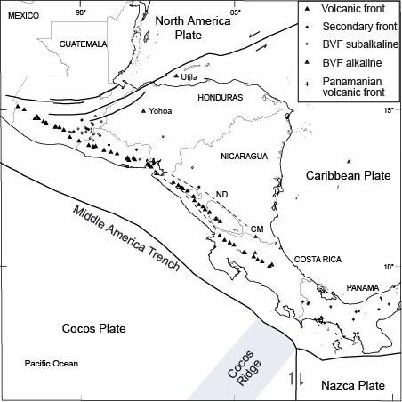

Figure 1. Location map for Central American volcanoes.
CM marks the location of Cerro Mercedes. Dashed lines mark position of Nicaraguan Depression (ND).

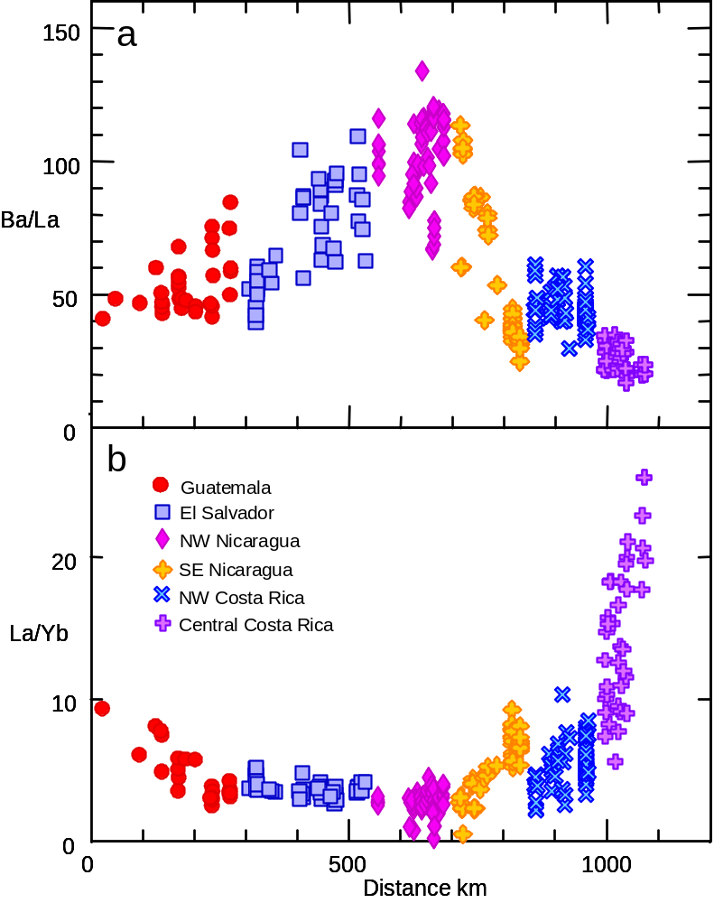

Figure 2. Correlation between sediment signal (Ba/La) and apparent degree of melting (inverse to La/Yb).
All samples are highest quality trace element data from the volcanic front. Samples lacking the normal large HFS depletion are not included.

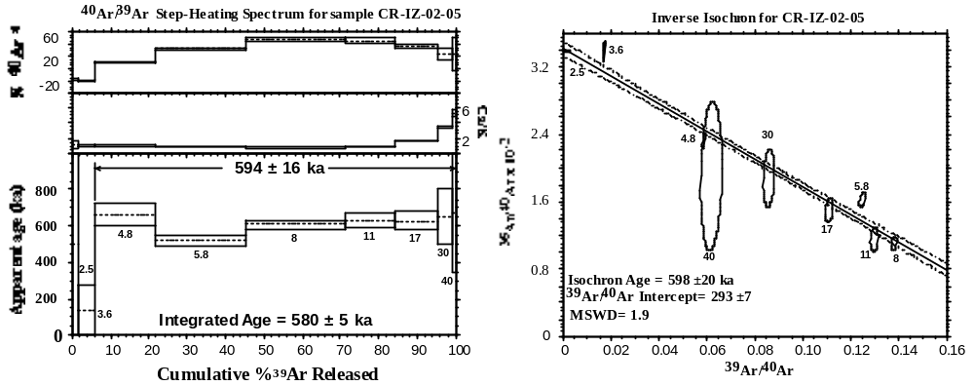

Figure 3. Step-heating spectra for sample from Irazú (CR-IZ-02-05).

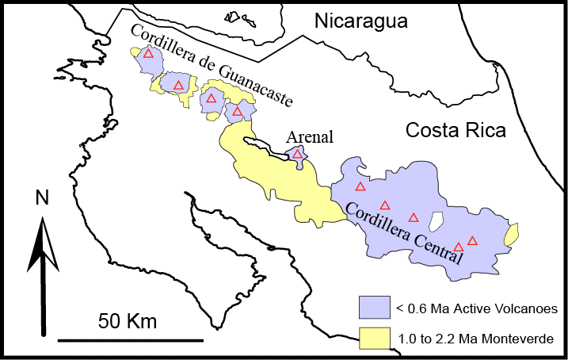

Figure 4. Sketch map of Monteverde Formation and younger volcanics (<600 ka) in Costa Rica.

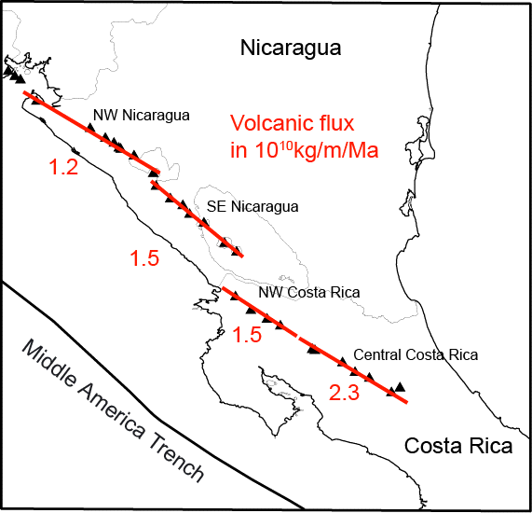

Figure 5. Volcanic flux by segment.
The NW Costa Rica segment of the volcanic front includes the Cordillera de Guanacaste volcanoes. The central Costa Rica segment includes Arenal volcano and the Cordillera Central volcanoes.

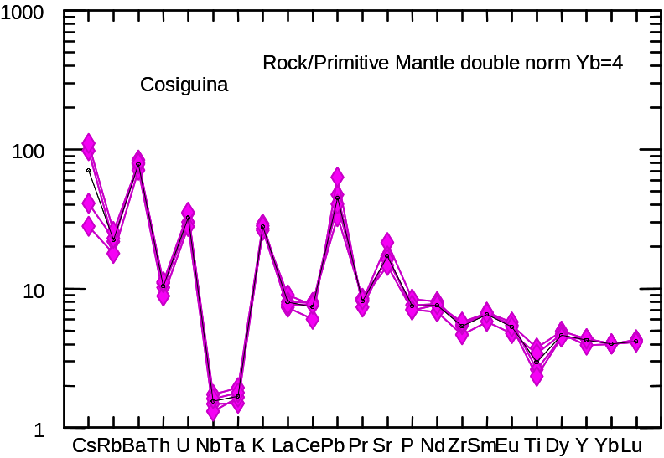

Figure 6a. Four samples used to determine mean value for Cosigüina volcano.
These are basalts to andesites (mean has 55 wt. % SiO₂). Ti is low because it is removed in magnetite. The mean is the black line. Normalization is from Sun and McDonough 1989 with double normalization (at Yb=4) to minimize effects of fractional crystallization.

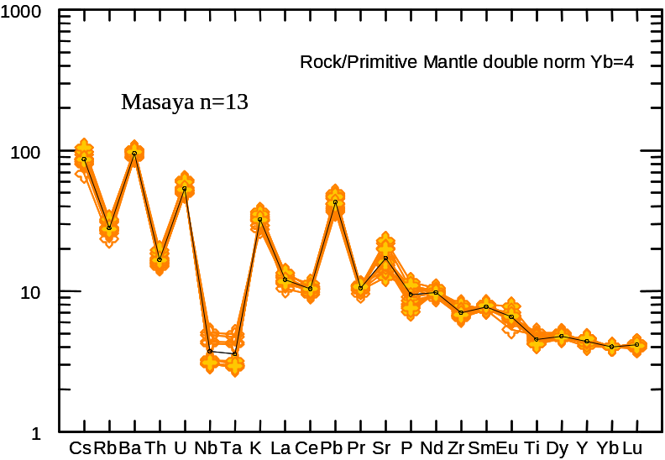

Figure 6b. Samples used to determine mean value for the Masaya volcanic center. These are basalts (mean has 50.8 wt. % SiO₂) that have experienced a tholeiitic fractionation pattern leading to high FeO. The mean is the black line. Normalization is from Sun and McDonough (1989) with double normalization (at Yb=4) to minimize effects of fractional crystallization.

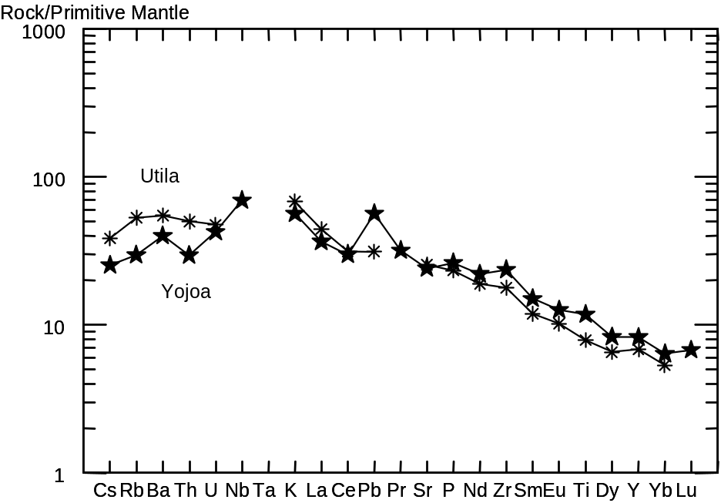

Figure 7. Alkaline back-arc lavas from Honduras.
These lavas have relatively smooth patterns when normalized using PM values, suggesting the PM normalization is appropriate for Central America.

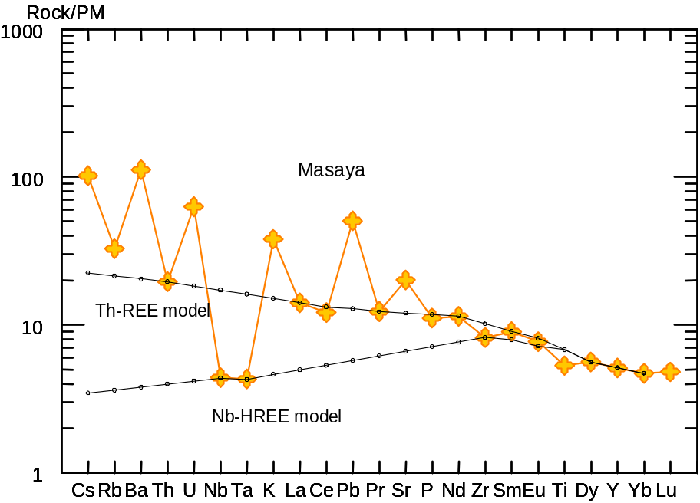

Figure 8. Mean value of Masaya volcano and two models of the mantle.

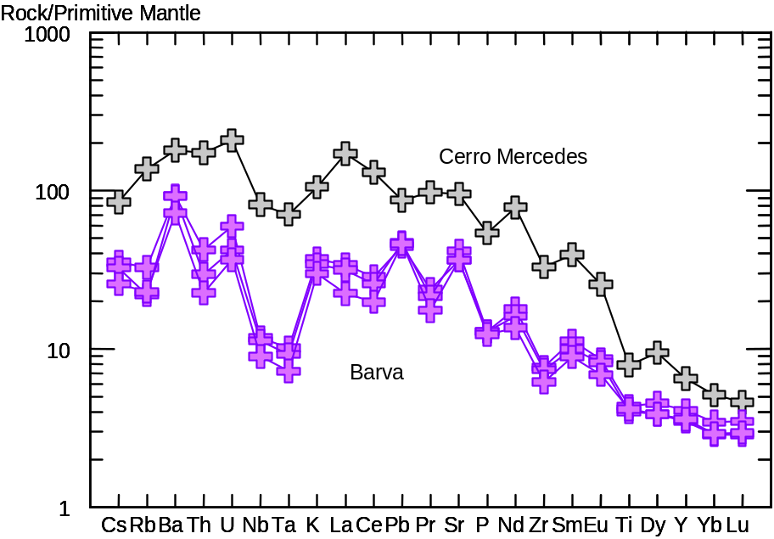

Figure 9. Three lava samples from Barva volcano and one from Cerro Mercedes.

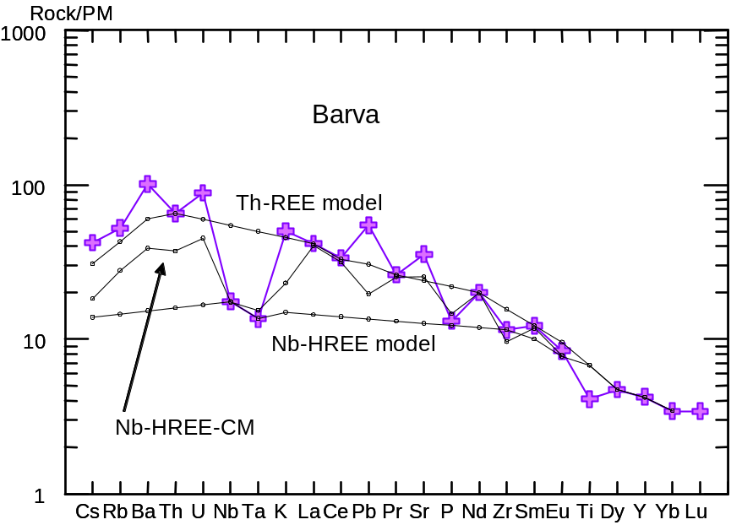

Figure 10. Three mantle models for Barva volcano.
Purple crosses are the mean composition of the Barva suite with highest slab signal. The three mantle contribution models are black circles.

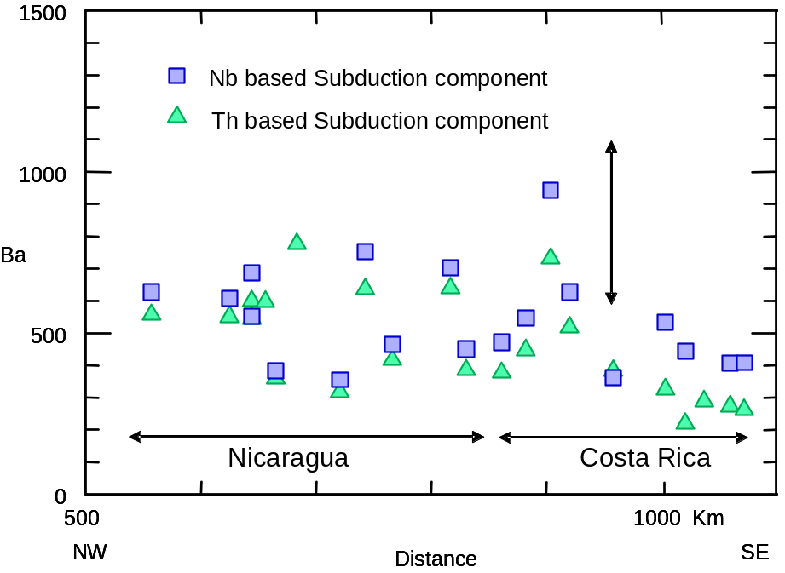

Figure 11. Ba concentrations estimated for the subduction component across Nicaragua and Costa Rica. Both the Th and Nb based models show a decrease in Ba concentrations for central Costa Rica, the region to the right of the vertical arrow.

