Field Study of the Grand River, Grand Rapids Michigan

Introduction
Flooding is a major concern for cities that have grown along major rivers. Factors that influence flood potential include climate (precipitation and temperature), channel characteristics (steepness, roughness), human modifications to natural levees, and urbanization. Grand Rapids has had nine major floods in the last 95 years, the most recent in 1985. The following field exercises are designed to introduce your awareness and knowledge of floods and flood hazards.

Field Exercise 1: Channel Cross-section and Stage
A major control of river behavior is the width and depth of the channel relative the volume of water being transported. During most years, the volume of water is small enough to be contained in the stream channel. In rare years, the volume of water is large enough to fill the stream channel or overtop the levee and cause flooding. The goals of this exercise are to draw a scale cross-section of the Grand River channel and to determine the current stage (height) of the river.

Constructing a Cross-Section
Making Measurements: Two standard geology field techniques will be used to make a quick, rough-draft cross-section. The width of the channel can be estimated by pacing and the height of the levee (banks) can be estimated by using your eye height and a hand level. Your pace is the distance you cover every time your right (or left) heel touches the ground. To determine your average pace length, count your steps as you walk100 feet. Divide 100 feet by your number of paces. To determine your eye height, use a measuring tape.

You need to make three width measurements. Start on the levee or floodwall on one side of the bridge. Count your paces until the base of the levee meets the river. Count your paces as you walk across the river. On the other side, count your paces from the stream to the top of the levee. Record your measurements on the simplified cross-section below.

width of levee width of channel width of levee

⏐←⎯ ___ ⎯→⏐←⎯⎯⎯⎯⎯⎯⎯⎯⎯⎯___ ⎯⎯⎯⎯⎯⎯⎯⎯⎯→⏐←⎯ ___ ⎯→⏐

x ↑ ↑ x
x x
x ___ height of levee ___ height of levee x
x x
x ___ depth of water ___ depth of water x x x x
↓ x x x x x x x x x x x x x ↓

To measure vertical changes in the shape of the channel you need to measure the height of the levee (above the river) and the depth of the water. To determine the height of the levee use your eye height and the level in the method shown by this diagram:

Record the height of the levee on the simplified cross-section above. Measure the water depth by lowering a weighted string into the river. Pull the string back up and measure the length of the wet part of the stream.
Plotting the measurements. To make a cross-section, plot your measurements on the graph paper using a scale of 1 inch equals 100 feet.

Use your data and cross-section to answer the following questions:
- What is the current depth of the Grand River?
- What is the current cross-sectional area of the Grand River?
- At what depth would the river completely fill its channel?
- What is the cross-sectional area of the Grand River when it completely fills its channel?

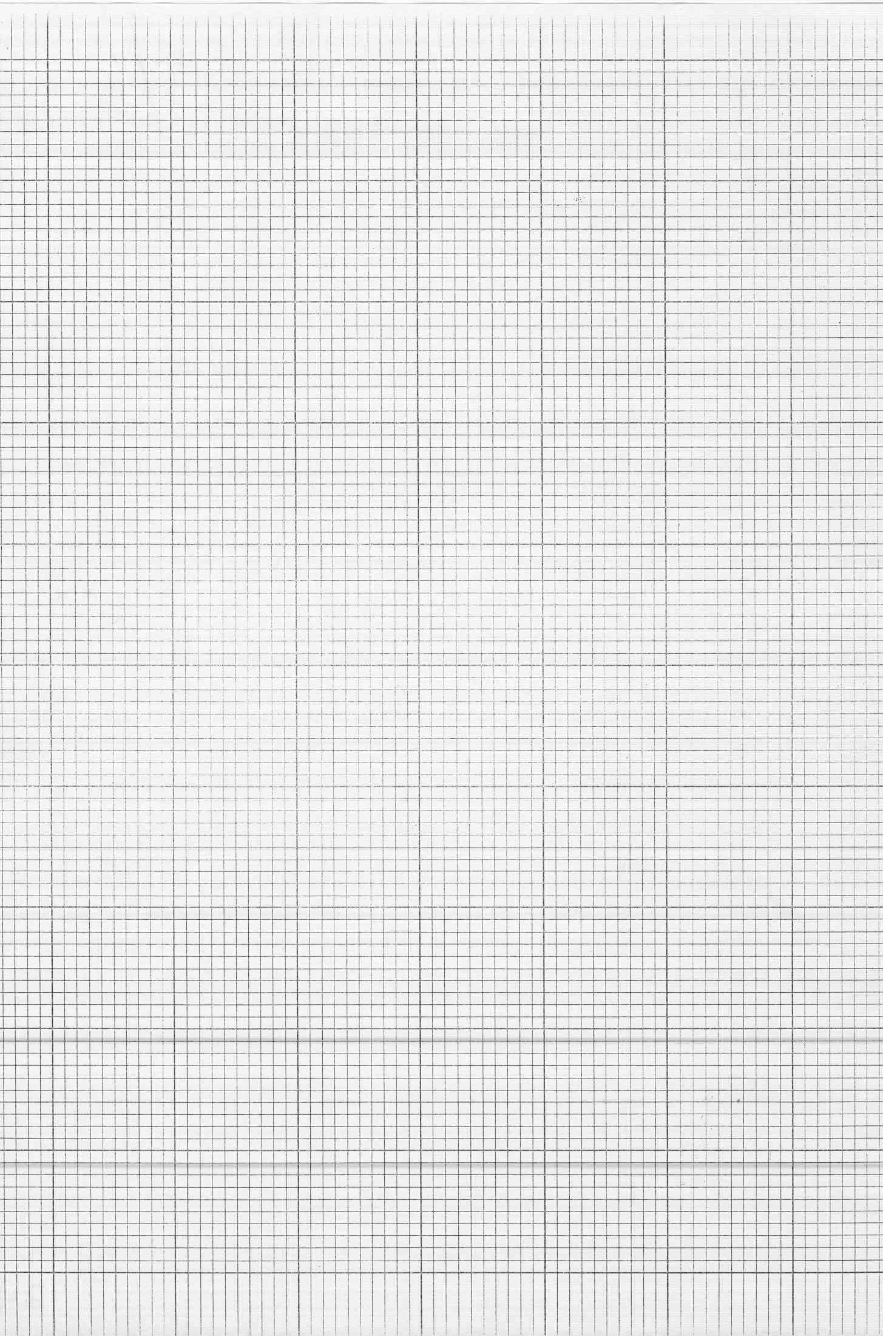

Field Exercise 2: Discharge
Discharge is the amount of water flowing past a point in a specific time interval. Units are ft³/s or m³/s. Knowing the volume of water in a river is important for predicting floods and for using the water as a resource (household, agriculture, and industrial uses). Discharge is equal to the width x depth x velocity of the river.
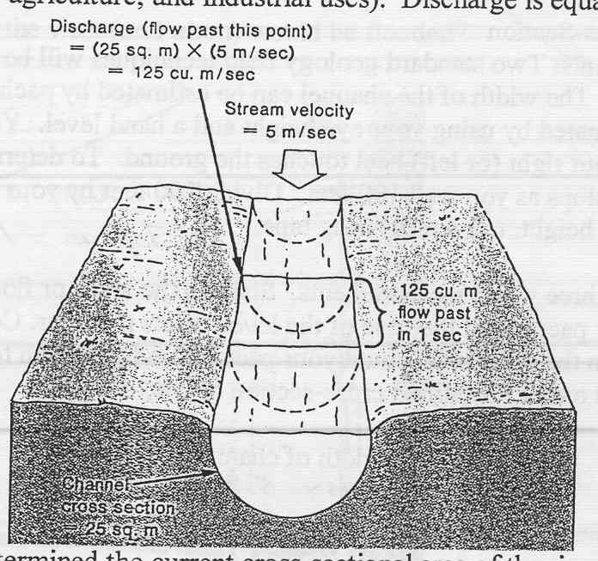
In the previous exercise, you determined the current cross-sectional area of the river. In this exercise you need to measure the velocity of the river and do some simple math to determine the current discharge of the Grand River. Velocity equals distance per time (ft/s). Split your team in half. Part of the team stays on the footbridge. The other part of the team measures the distance between the footbridge and the Fulton Street Bridge (use your pace distance) and then walks out on the sidewalk (BE CAREFUL, Fulton Street is busy). Get a watch ready. Have the team on the footbridge drop a float in the river (an orange or a piece of wood). Measure the amount of time it takes for the float to travel down to the Fulton Street Bridge.

velocity = distance = ______feet = ft
time sec s

Our techniques was simple and cheap, the U.S. Geological Survey now uses Acoustic Doppler Current Profilers to make measurements of velocity and discharge in rivers.

Now it’s easy to calculate discharge:

discharge = width x depth x velocity = ______ feet x _____ feet x _____ feet/sec = _____ ft³/s

During the 1904 flood of the Grand River discharge reached 54,000 ft³/s.

Field Exercise 3: Human Modifications to the River
Lateral erosion by a river and deposition during floods builds floodplains and natural levees. Over time, the river has a natural tendency to meander back and forth across the floodplain. As an area becomes developed, people stabilize the levees, in some cases modifying them extensively, and they build on the adjacent floodplain. For the most part we force the river to stay within a manmade channel. In this exercise you will examine and describe the levee/channel walls adjacent to the Grand River.

Describe the levee/channel walls from the Eberhard footbridge to Pearl Street along the west side of the river.

Describe the levee/channel walls from the Pearl Street to the footbridge near the Gerald R. Ford Museum along the west side of the river.

Describe the levee/channel walls in front of the Gerald R. Ford Museum.

Cross the footbridge.
Describe the levee/channel walls from the footbridge to Pearl Street along the east side of the river.

Describe the levee/channel walls from Pearl Street to the Eberhard footbridge along the west side of the river.

Use your observations to answer the following questions:
Where are the river channel walls the least modified?

Where are the river channel walls the most modified and how is it modified?

During a major flood will the least modified or most modified channel walls better contain the river?

Can you suggest any disadvantages to extensively modifying the channel walls?

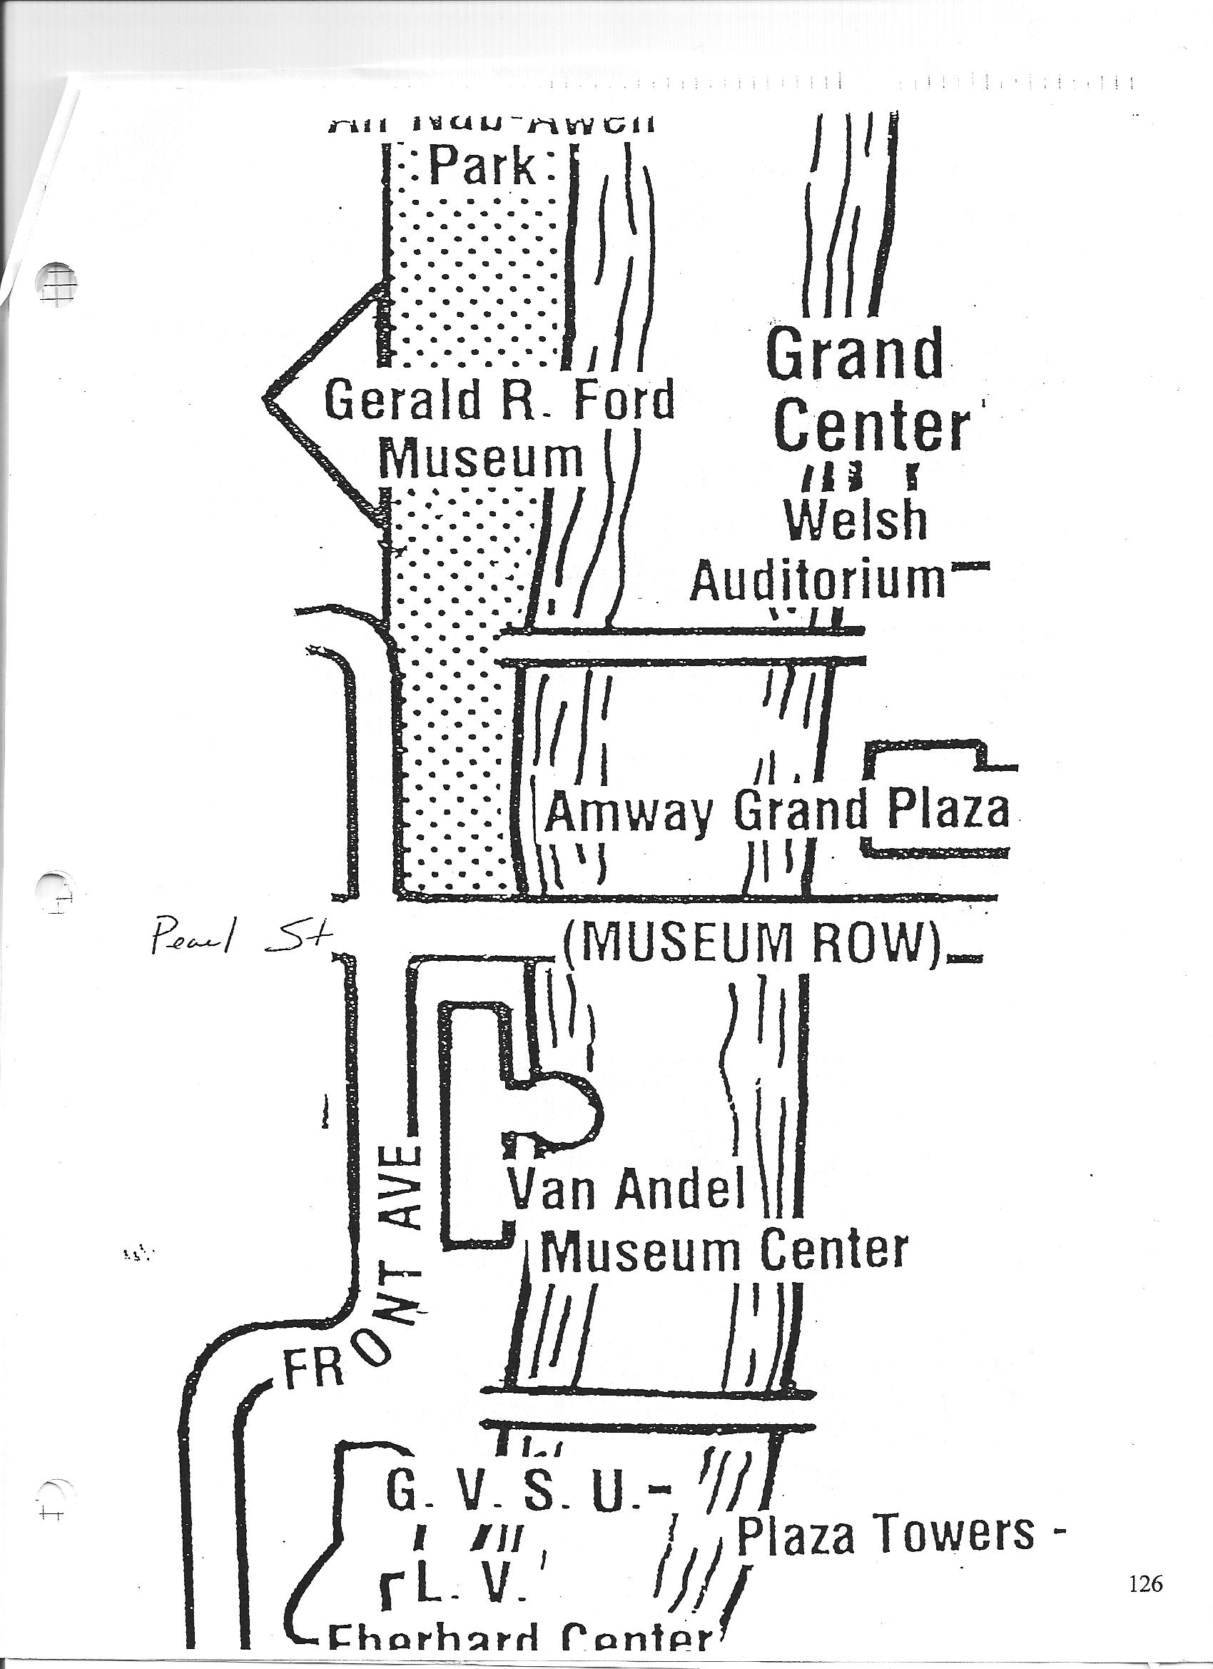
Field Exercise 4: Impact of Future Floods

It is difficult to visualize familiar places under several feet of water. This simple exercise puts you at a familiar location and provides a visual estimate of the height of the water during the 100-year flood.

Take the stadia (surveyors) rod to the northeast corner of the intersection of Front and Fulton Streets (just southwest of Eberhard). Have one member of the team hold the rod vertical. During a 100-year flood, the water would rise four feet above the sidewalk at this location.

Answer the following questions:
- Would road traffic in the area be disrupted?

- Would the first floor of Eberhard be flooded?

- Would other significant structures be flooded? If yes, which ones?

- Can you estimate how far to the west (on Fulton) would be flooded?

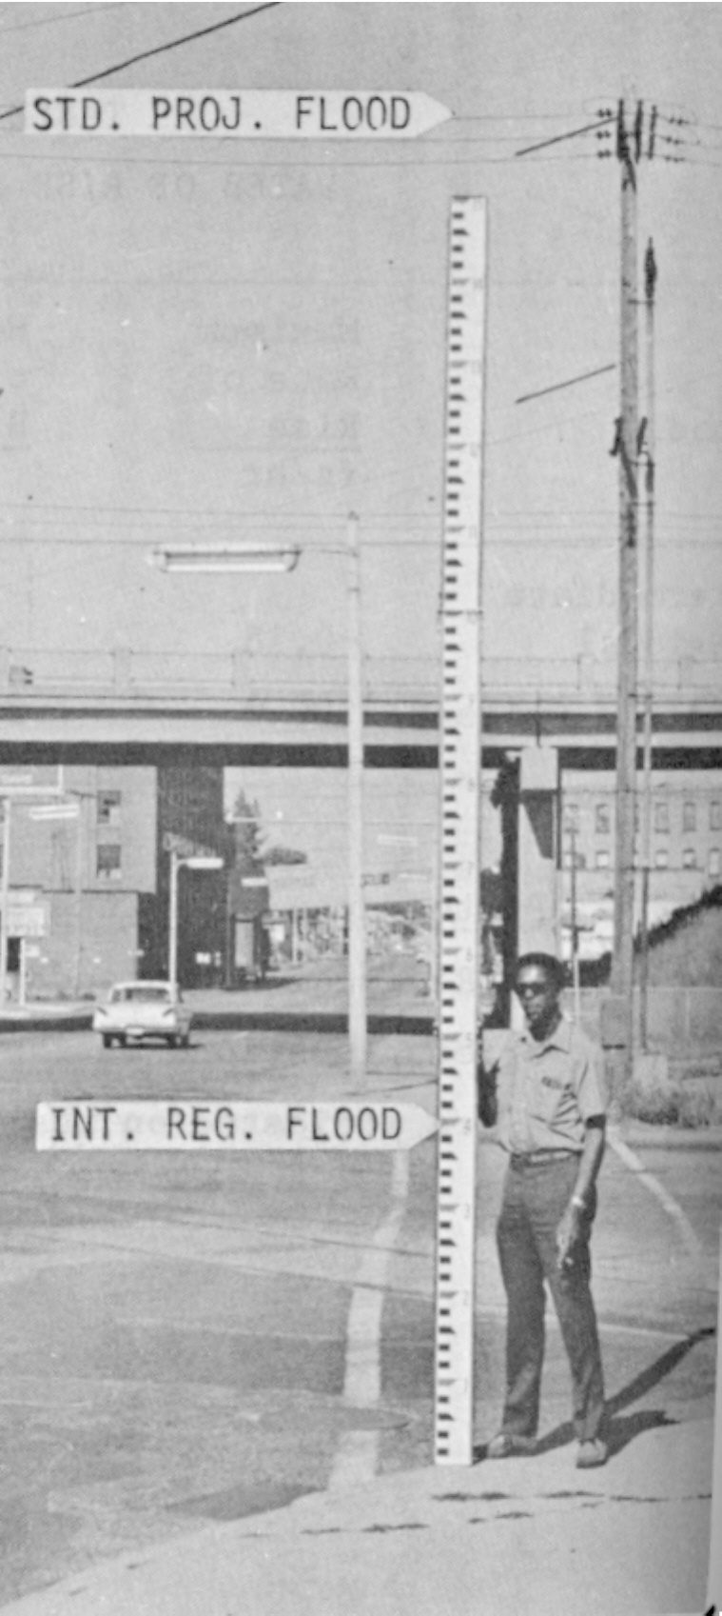

Past and Future Floods in Grand Rapids, Michigan

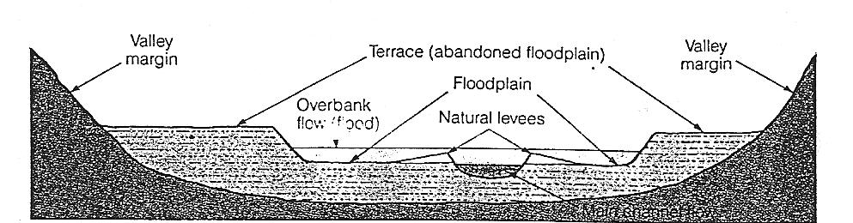

Introduction
Flooding, a river extending beyond its natural levees, is a natural geologic process. This process puts human lives and property at risk when people live in and develop areas adjacent to rivers. The city of Grand Rapids was founded on the Grand River in 1850. The river served as a highway to send materials to and from Lake Michigan. The river also served as an abundant, free power source, prompting more people to move to the area. As the city grew, development increased on the floodplain, the gently sloping area adjacent to the river. Homes and businesses on the floodplain were at risk.

As the river moves through Grand Rapids, the elevation of the river banks decrease from an elevation of about 610 feet in the north to 590 feet in the south. In the city, the river channel is about 500 to 600 feet wide.

Table 1 shows data for all major floods in Grand Rapids from 1901 to 1972.

Table 1.
Date of Crest | Stage  (feet) | Elevation  (feet) | Discharge (cubic  feet per second)
March 28, 1904 | 22.5 | 608.20 | 54,000
June 9, 1905 | 21.6 | 607.30 | 50,200
April 7, 1912 | 19.20 | 604.90 | 30,600
March 30, 1916 | 18.90 | 604.60 | 30,600
March 20 1942 | 18.12 | 603.82 | 34,000
April 9, 1947 | 19.42 | 605.12 | 38,600
March 23, 1948 | 20.02 | 605.72 | 42,200
April , 1960 | 19.25 | 604.95 | 31,800
March 1, 1985 | 19.64 |  | 30,200

Along most of the east side of the river, a floodwall protects downtown Grand Rapids. The top of the floodwall is above the floodplain. If the river rises above the floodwall, parts of the city will be flooded. Along the west side of the river, the river is contained by floodwalls and modified segments of the natural levee. Residences and small businesses are located on this side of the river but demands for space are resulting in construction of new major structures, including GVSU’s Eberhard and DeVos centers.

Purpose
Large floods occur infrequently. According to Table 1, most Grand Rapids residents might remember one or 2 major floods in the last 50 years. Most students (pre-college and college) have probably never thought about the Grand River flooding and the social and economic impacts of a major flood. This activity is designed to increase awareness of flood frequency and the potential impacts of floods.

Hypothesis
A hypothesis is a question which has been reworded into a form that can be tested by an experiment.

Students will be asked to formulate hypotheses to be tested. Possible hypotheses include:
Is the Eberhard Center safe from floods during the lifetime of the building?
Will the Eberhard Center be flooded if the river rises 10 feet above its present level?
Are homes and businesses above an elevation of 605 feet likely to be flooded?

The two hypotheses addressed by this lesson are:
How frequently will Grand Rapids experience large floods?
What areas are most prone to flood damage?

Procedure
This lesson will be divided into two independent activities. Activity 1 uses historical data (Table 2) to construct a flood frequency curve and explores the significance of this diagram. Activity 2 uses the data you collected in the field and the topographic map of downtown Grand Rapids to estimate the impact of floods.

Activity 1: Flood Frequency in Grand Rapids

Materials
- annual peak discharge for the Grand River (see below)
- linear versus log graph paper

Data/Manipulation
The U.S. Geological Survey has recorded the stage and discharge of the Grand River in Grand Rapids since March 1901. These data are now available on the Survey’s Real Time Water Data web page (see http://water.usgs.gov/realtime.html; station 04119000 Grand River at Grand Rapids, Mich.) and provided in Table 2.

Results
Plot the data in Table 2 on the graph paper. Draw a best-fit curve through the data points (analytical computation of the best-fit line can cause the curve to shift to an unrepresentative position). The line is the flood-frequency curve for the Grand River in Grand Rapids.

Interpretation and Analysis
Flood-frequency curves are used to estimate the probability of floods greater than certain limits. The information is needed for engineering design, planning flood insurance, and land zoning in flood prone areas. Use your flood-frequency curve to answer the following questions:
1. In any given year, what is the minimum discharge of the Grand River?
2. How does this number compare to the discharge you measured on August 26th? Formulate a reasonable (geologic or climatic) hypothesis on why the two numbers are different.
3. On average, what is the maximum discharge seen on the Grand River every 10 years?
4. In any given year, what is probability of a flood occurring with a discharge of 30,000 ft³/s?
5. What is the discharge of a flood with a recurrence interval of 100 years (probability of occurrence = 1% in any given year)?
6. Is it possible to have two 100-year floods in consecutive years? Table 2 might help. Explain your answer.
7. Estimate the discharge of a 500-year flood in Grand Rapids.

m | Q | RI
1 | 54000 | 97
2 | 50200 | 48.5
3 | 42200 | 32.3
4 | 38600 | 24.2
5 | 34000 | 19.4
6 | 32400 | 16.2
7 | 32400 | 13.9
8 | 31800 | 12.1
9 | 30600 | 10.7
10 | 30600 | 9.7
11 | 30200 | 8.8
12 | 30000 | 8.1
13 | 29200 | 7.5
14 | 28800 | 6.9
15 | 28300 | 6.5
16 | 28300 | 6.1
17 | 28300 | 5.7
18 | 28000 | 5.4
19 | 27600 | 5.1
20 | 27200 | 4.9
21 | 26800 | 4.6
22 | 26700 | 4.4
23 | 26000 | 4.2
24 | 24600 | 4.0
25 | 23600 | 3.9
26 | 23500 | 3.7
27 | 23000 | 3.6
28 | 23000 | 3.5
29 | 22300 | 3.3
30 | 22300 | 3.2
31 | 21400 | 3.1
32 | 21000 | 3.0
33 | 20800 | 2.9
34 | 20600 | 2.85
35 | 20500 | 2.77
36 | 20000 | 2.69
37 | 19800 | 2.62
38 | 19200 | 2.55
39 | 19000 | 2.48
40 | 19000 | 2.42
41 | 18900 | 2.36
42 | 18500 | 2.31
43 | 18300 | 2.25
44 | 18100 | 2.20
45 | 18000 | 2.15
46 | 18000 | 2.10
47 | 17800 | 2.06
48 | 17800 | 2.02
49 | 17500 | 1.97
50 | 17400 | 1.94
51 | 17300 | 1.9
52 | 17100 | 1.86
53 | 16900 | 1.83
54 | 16900 | 1.79
55 | 16400 | 1.76
56 | 16200 | 1.73
57 | 16200 | 1.70
58 | 16100 | 1.67
59 | 15900 | 1.64
60 | 15000 | 1.61
61 | 14800 | 1.59
62 | 14800 | 1.56
63 | 14500 | 1.54
64 | 14200 | 1.51
65 | 13800 | 1.49
66 | 13000 | 1.47
67 | 13000 | 1.45
68 | 12800 | 1.42
69 | 12700 | 1.41
70 | 12400 | 1.39
71 | 12000 | 1.36
72 | 12000 | 1.34
73 | 11900 | 1.33
74 | 11800 | 1.31
75 | 11600 | 1.29
76 | 11500 | 1.27
77 | 11500 | 1.26
78 | 11500 | 1.24
79 | 11200 | 1.23
80 | 11000 | 1.21
81 | 10900 | 1.20
82 | 10400 | 1.18
83 | 9920 | 1.17
84 | 9800 | 1.15
85 | 9800 | 1.14
86 | 9450 | 1.13
87 | 9290 | 1.11
88 | 9170 | 1.10
89 | 8890 | 1.09
90 | 8820 | 1.07
91 | 8700 | 1.06
92 | 8680 | 1.05
93 | 8500 | 1.04
94 | 8500 | 1.03
95 | 8090 | 1.02
96 | 5680 | 1.01
97 | 3200 | 1

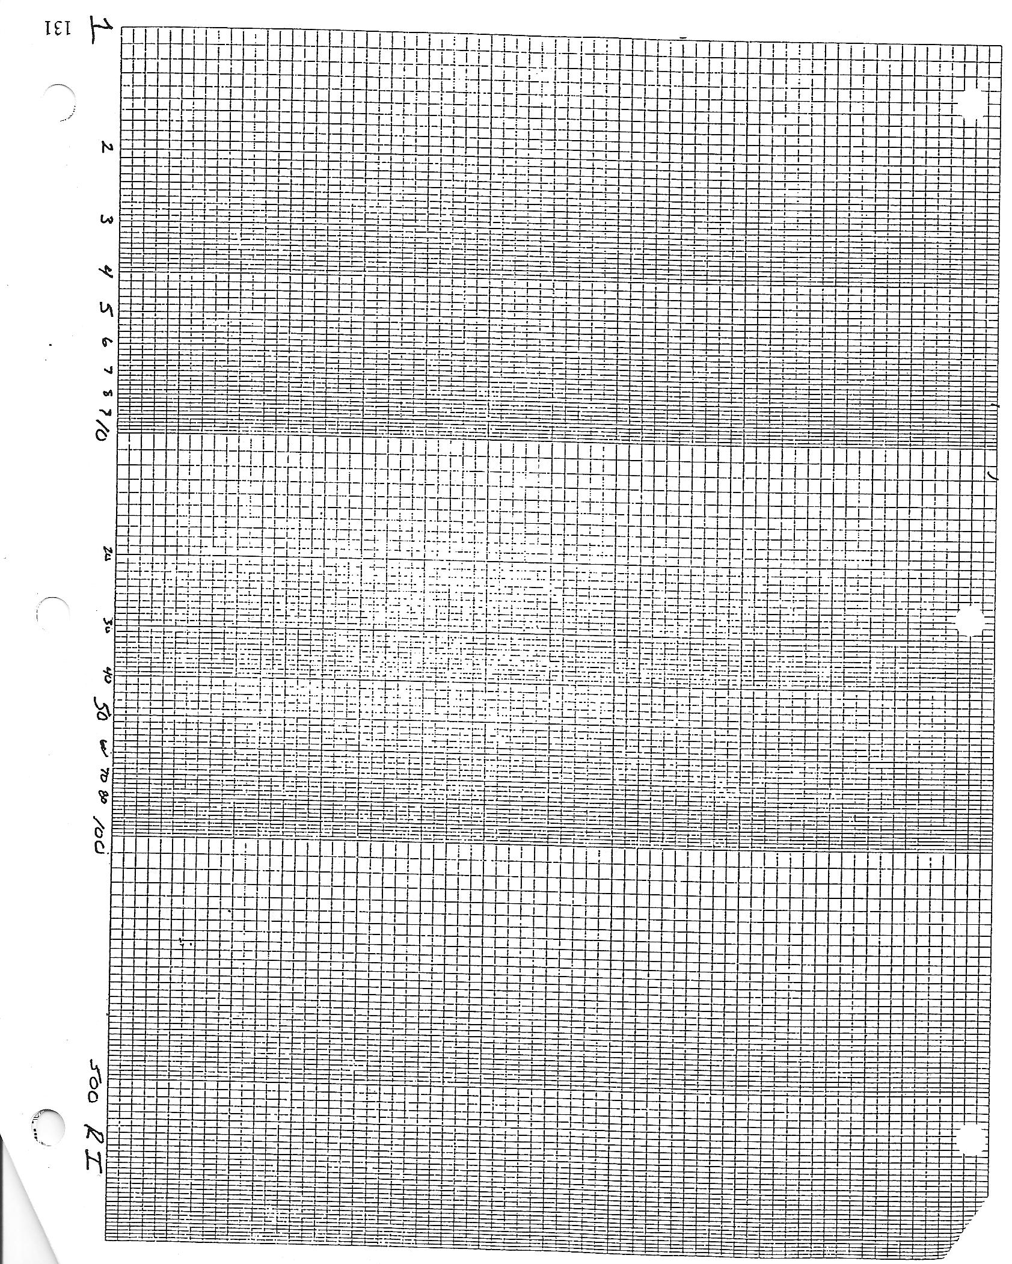

Activity 2: Impacts of Floods in Grand Rapids

Hypothesis: What areas are most prone to flood damage?

Procedure
When combined with topographic data (the elevation and shape of the land), flood data can be used to plan development along a river and to estimate the impact of future floods. Models are commonly based on large historic floods, such as the March 1948 flood (discharge = 42,000 ft³/s), the 100-year flood (sometimes called the intermediate regional flood), and the standard project flood (the largest flood that can be expected from the most severe combination of meteorological and hydrological conditions). In this activity we will mesh your field observations from August 26th with historic flood data and the data presented on topographic maps to estimate the areas likely to be flooded and the potential impacts of these floods. Topographic maps show elevations and landscape features such as hill, rivers, lakes, and creeks. Man-made structures, such as highways, roads, buildings, bridges, railroads, cemeteries, quarries, and parks, are also shown.

Materials: - data from field exercise on August 26
- USGS topographic map of Grand Rapids

Data/Manipulation
How high can the river rise? The datum for the gauging station near Eberhard is at 585.7 feet. Table 1 shows the stage (elevation) of the river during major floods. For example, during the 1904 flood the river reached an elevation of 608.2 feet, 22.5 feet above the datum. The discharge of the 100-year flood is 61,000 ft³/s. The stage for the 100-year flood in Grand Rapids is 612.73 feet. What areas will be covered? We need to compare this stage to the elevations of the floodplain in Grand Rapids.

Results
Even with flood mitigation measures implemented after the 1904 flood, large sections of Grand Rapids, especially west of the river, will be flooded during a 100-year event. On the map provided, quickly shade the areas that will by inundated if the water rises to about 612 feet.

Interpretation and Analysis
To better understand the impacts of the 100-year flood answer the following questions:

- What is the approximate elevation of the river gage station near the Eberhard Center?

2. What is the approximate elevation where the floodplain meets the valley wall to the west of the Grand River (the base of the hill at John Ball Park)?

- Will the Eberhard and DeVos centers be flooded during a 100-year flood?

- Describe the disruption to traffic on the west side of the river.

- Describe the disruption to industry on the west side of the river.

- Will the flood impact the sewage treatment facility you visited on August 26th?

- Should homeowners and businesses on the west side of the river be required to have flood insurance or should the federal government pay for flood damage?

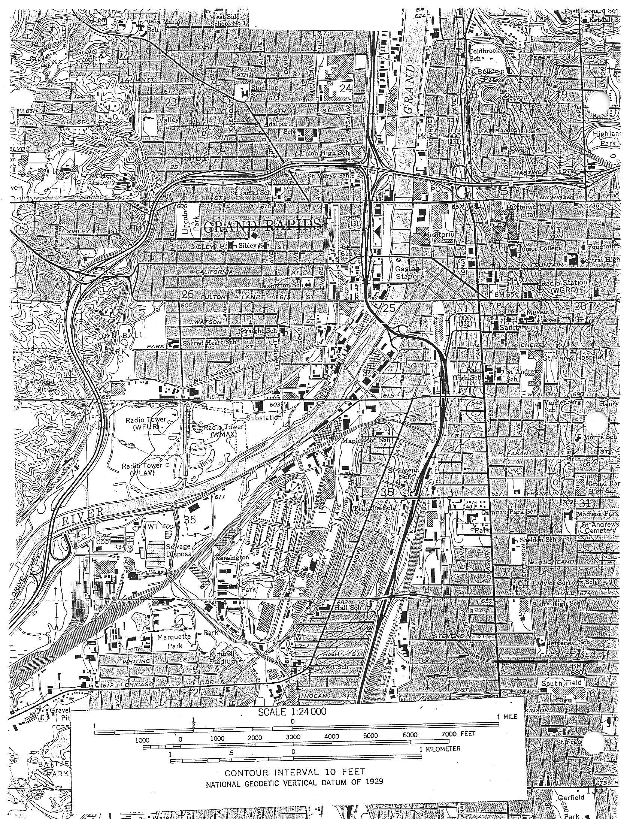

Flood-frequency Data for the Grand River, 1901-1999

Discharge | Number of Years at this Discharge
0-1000
1001-2000
2001-3000
3001-4000 | 1
4001-5000
5001-6000 | 1
6001-7000
7001-8000 | 1
8001-9000 | 4
9001-10,000 | 6
10,001-11,000 | 3
11,001-12,000 | 8
12,001-13,000 | 6
13,001-14,000 | 1
14,001-15,000 | 5
15,001-16,000 | 1
16,001-17,000 | 6
17,001-18,000 | 8
18,001-19,000 | 5
19,001-20,000 | 4
20,001-21,000 | 3
21,001-22,000 | 2
22,001-23,000 | 4
23,001-24,000 | 2
24,001-25,000 | 2
25,001-26,000 | 1
26,001-27,000 | 2
27,001-28,000 | 3
28,001-29,000 | 4
29,001-30,000 | 1
30,001-31,000 | 3
31,001-32,000 | 1
32,001-33,000 | 1
33,001-34,000 | 1
34,001-35,000
35,001-36,000
36,001-37,000
37,001-38,000
38,001-39,000 | 1
39,001-40,000
40,001-41,000
41,001-42,000
42,001-43,000 | 1
43,001-44,000
44,001-45,000
45,001-46,000
46,001-47,000
47,001-48,000
48,001-49,000
49,001-50,000
50,001-51,000 | 1
51,001-52,000
52,001-53,000
53,001-54,000 | 1
54,001-55,000

